CIBC RSI 3

RSI Overview Deliverables 3

Risk Model & Sensitivities 3

Interest Rate Risk 3

Credit Spread Risk 3

Analytics 3

Analytics OLSM 3

Market Risk 3

Market Risk Data 3

Incremental Risk Charge (IRC) 3

Regulatory changes 3

Metrics to calculate regulatory capital for market risks 3

Stressed VaR 4

VaR, IRC, Stress test Performance 4

Back testing 4

EOD Feed schedule 5

Enhanced VaR Tactical 5

IMA (Internal Model Approach) *Documents to be submitted* 5

OSFI Initiatives 5

Business Case 5

Plan 5

Work streams 6

Credit Risk 6

Requirements 6

Credit Risk Use Case 6

Credit Risk Exposure 6

Credit Risk Terminology 6

Credit Valuation Adjustment (CVA) 6

CIBC Risk systems 7

Voyager (Market Risk) 7

TRACS (Credit Risk) 7

CIBC 5 Asset Classes by 29 Systems 8

SUNGARD 9

MUREX 9

Risk IT Architecture 10

Risk Data Management 10

Financial Risk Topics 11

Stress testing framework 11

Risk appetite 11

Liquidity Risk 12

Overview 12

Cash flow landscape 12

Fund transfer pricing with liquidity risk 12

Contingent liquidity pricing for a facility 12

Contingent Cash Flow Funding Risk (CCFR) for derivatives 12

Non-trading risk 12

WESTPAC Definition 12

Non-Trading Book Exposures in Equities (Lloyds bank) 12

Basel III 12

Overview 12

Regulatory Objectives 13

Timeline 14

Enterprise Risk 14

ERM framework 14

Risk Appetite, Assessment, Measurement 14

Risk Type - Risk Management 14

Risk Models 14

Identifying Top Risks 15

Financial Regulation 15

Operational Risk 15

COSO 15

Operational Risk 15

4 types of losses 15

BIS Definition 15

Risk Identification, Type, Cause 15

Event, Category, Activity 16

Assessment Approach 16

1 Input to Risk Catalogue 16

2 Risk Assessment Scorecard 16

3 Review and Validation 16

Output of assessment process 16

OR Tools 17

OR Management System 17

Operational Risk Management System 17

OR in the context of risk 17

Key Risk Indicator (KRI) 17

12 KRI 17

Objectives, Strategies, Risks, KRI’s 17

KRIs to Inform About Risk of Debt Covenant Default 17

KRI for Operational Risk 18

Enterprise Risk Management Schematic 18

HOOPP 18

Middle office processes 18

Collateral Business 18

Straight-through Processing STP 18

Dodd-Frank 18

HOOP considerations 18

HOOPP Plan 18

System capabilities for OTC derivatives central trading and clearing 18

Straight Through Processing STP 18

Market infrastructure 19

HOOPP Process for transacting & clearing a trade 19

SIMCORP 19

On SCD EQUITY 19

On Collateral 19

On SCD Fixed Income 19

Functions & Modules 20

AIDC Financial Management and Treasury 20

Manulife OTTI (Other than Temporarily Impaired) 20

AIA/AIG 20

P&C 20

AIG Credit Card 20

CIBC Control 20

CIBC 20 Services (Financial) 20

CIBC Processes (FCU) 20

CIBC 26 Processes (OPC) – 113 Sub-processes 21

CIBC Legislative Compliance Management (LCM) 22

British Columbia Workplace Technology Services 22

Balance Scorecard and Performance Measures 22

Learning & Growth - Customers 22

Internal Business Processes and Financial 22

Corporate Accounting System (CAS) 23

Business Transformation Initiative (BTI) 23

CIBC Mellon 24

History 24

Business & Process 24

⬩Distribution and service fees 24

MIS Dashboards 24

Balance Scorecard Internal - GSS Trade Settlements 24

Balance Scorecard Internal - CMT Securities Transfer 24

Balance Scorecard Internal - CMT & GSS Assets under Administration 24

Balance Scorecard Finance 25

Balance Scorecard Client 25

Balance Scorecard Learning & Growth 25

Scope 25

Project Plan 25

CIBC CAD Chief Accountant Scorecard 2005 25

Operations 25

Finance 25

Customer/Client 25

Growth 26

# CIBC RSI

## RSI Overview Deliverables

❶**Market Risk** General MR, IRC, Equity & Debt Specific Risk, Stressed VaR, Stress Testing ❷**Trading Credit Risk** CVA, Limits Monitoring, Stress Testing, Master Agreement Details, Pre-Deal Check, Ratings Maintenance ❸**Trading Operational Risk** Product Authorization, Limit Breaches, KRIs, Reporting❹**Analytics** VaR Methodology, Stress Testing, Model Calibration, Exposure Modeling❺**Economic & regulatory capital** IRC enhancement❻**Data/ reporting** Data quality, Master data management, Derived historical data, Unstructured data management, Standard/ad hoc reporting/analysis, Meta data

#### Risk Model & Sensitivities

❶**DGVRT** assumed MR factors log-normally distributed; statistical parameters based on 250 days of history; inputs (risk factor sensitivities, correlations, volatilities, average returns, market prices of risk factors) ❷**HistSimm** based on historical distribution of rolling 500 dailychanges in risk factors ❸**Debt Specific Risk** **DSR** default + idiosyncratic spread risk - MC model with 4 components: 1 *Marginal distribution calibration* to estimate/ calibrate spread return for each credit group 2 *Correlation calculation* 3 *Preprocessing* *4 Core* ❹**Approach** Use *spread simulation model;* small spread moves 🢧 spread *volatility risk*, larger moves 🢧 *migrations and defaults*; models **total credit spread** of individual bond as general spread + specific component; **general spread** from bond index given by observable index or inferred as average credit spread of basket of bonds comprising a Credit Group; **specific spread** component = difference between total credit spread inferred from bond’s observable price and sectorial spread; use 90 Credit Groups of bond indices, baskets of traded bonds, spanning markets, economic sectors, credit qualities maturities; use MC simulation to compute specific risk; join marginal distributions using copulae to model tail dependence embedded within credit spread data; model sector and specific spread distributions using Student’s t-distributions; calibrate historical bond index data to obtain distribution parameters via moment matching **Risk sensitivities** (45) equity/ metal/ oil/ FX DGVRT, duration e.g. *base metal vega risk*, *CS idiosyncratic risk*

#### Interest Rate Risk

❶**IR Outright and Curve risk** portfolio sensitivity to changes in yield curve (Frontier/ Voyager zero rate yield curves for sensitivity, VaR generation) ❷**IR Swap Spread risk** portfolio sensitivity to changes in spread between govt yields and swap yields ❸**IR Vega risk** sensitivity to changes in IR volatilities ❹**Total IR risk all IR risks + IR Theta** with correlations between IR components (zeroes, swap spreads, volatilities)

#### Credit Spread Risk

Due to change in spreads (bond index, government yields) ❶**Generic CS risk** change in spread (Treasuries, mapped bond index) ❷**Idiosyncratic CS risk** change in spread (specific issuer, mapped index)❸**Total CS risk** = Generic CS risk + Idiosyncratic CS risk assuming zero correlation

## Analytics

#### Analytics OLSM

(Optimized Least-Squares Monte Carlo) simulation to compute **potential future exposure (PFE)** **profile** of derivatives with complex optionality for which no analytic approximation exists; relies on **Least-Squares approximation** by Longstaff & Schwartz; traditionally **nested Monte Carlo MC** or **approx surrogate structured deal** computationally expensive & approximate **work streams** *IR & FX basis risk*, *Equity Dividend*, *Volatility Skew*, *Monte Carlo on Monte Carlo* **correlation risk** *equity-equity*, *commodity-commodity*, *commodity-FX* assets classes **dividend risk** measured through sensitivity based variance-covariance; *calculated for 1 bp change in dividend yield, applied to shocks based on dividend yield volatilities; dividend yield volatilities for indices based on time series of forward dividend yields and dividend yield volatilities for single stocks*

🕮**Analytics Model gaps**

## Market Risk

#### Market Risk Data

❶**Data groups IR market data** Yield/zero curves for bonds, swaps (zero curves bootstrapped from corresponding yield curves), spread curves, volatility cubes or surfaces, basis spread curves **Trading credit** CDS spreads, CDS indices **FX related** FX spot rates, FX volatility surface **EQ related** equity indices, common stock prices; equity volatility surfaces **Commodity related** commodity spot prices, commodity forward/future price curves, commodity price volatility surfaces ❷**Data structures** **Scalar asset spot prices** FX spot prices, equity spot prices, commodity spot prices bond prices **1-dim term structure curves** (1-dim vector data) IR yield/zero curves, IR spread curves, CDS spread curves, commodity forward/futures curves, ATM FX implied volatilities, commodity price volatilities, ATM equity implied volatilities **2-dim surfaces** ATM IR implied volatility surfaces, equity implied volatility skews, FX implied volatility skews **3-dim cubes** IR implied volatility skew cubes **Matrix market data** correlation metrics, transition probability metrics❸**Trade data** **Instrument** (security term & conditions, Security, Debt, Option, Future, Forward) **Instrument Type** (product type) **Trade** (daily trade position information) **Structured Product**, **Cash Flow**, **Schedule** (average rate schedule, payment Schedule, reset schedule, amortizing schedule, exercise schedule) **Instrument state** (daily basis ‘NEW’, ‘SG_DONE’, ‘SG_RESULTS_LOADED’) ❹**CIBC MHS (market data store)** central repository for Voyager (market risk minus specific risk), Euclid (specific risk), TRACS (credit risk) ❺**Types** 1-market data 2-variance/ covariance (derived market data) 3-statistical parameters (derived market data) ❻**Feeds** generates 76 market data feeds (34 feeds in MR) 30+ FO systems (1 feed 1 system)

#### Incremental Risk Charge (IRC)

⓿**What?** Loss due to default/changes in quality at 99.9% CI over 1 year ❶**Phase 1** MC simulation of *Merton structural model* for default/credit migration **Phase 2** MC simulation of credit/equity states based on *Stochastic Volatility model* (stochastic price + variance process driven by Brownian motions with constant linear correlation) ❷**Phase 1 design** **①**Parameterize correlation with concentration parameter to couple issuer/ market concentrations to migrations and defaults **②**Constant level of risk (same loss distribution over liquidity horizon 3 months liquid within 1 year horizon) **③**Aggregation/liquidity horizon correlation – use hedge for sub-portfolios with multiple liquidity horizons **④**Valuation – principles (full valuation; same valuation by front and risk); for equities no model needed (prices simulated directly) ❸**Credit Spread & Mark-To-Market Adjustment** - 2 credit spread types: **①**CDS spread: bond spread, can differ in magnitude for technical reason; **②**Bond spreads: yield spread, asset swap spread, option adjusted spread (OAS or Z-spread), interpolated spread (I-spread) available on Bloomberg ❹**Plan** **⓪**Contingency (standardized approach) **①**Risk model (requirement, development, unit test) **②**Market data (requirement, document, unit test) **③**Trade position data (requirement, development, unit test, SIT, UAT, Regression) ❺**Gap analysis** **①**Products (structured credit run-off portfolio) **②**Position data (instrument type, business entity for aggregation -- insufficient id of securitized position, parallel effort to standardize DSR treatment, banking book/ securitization treatment) **③**Market data (credit spreads per currency/sector/rating - insufficient sector coverage, better granularity)

#### Regulatory changes

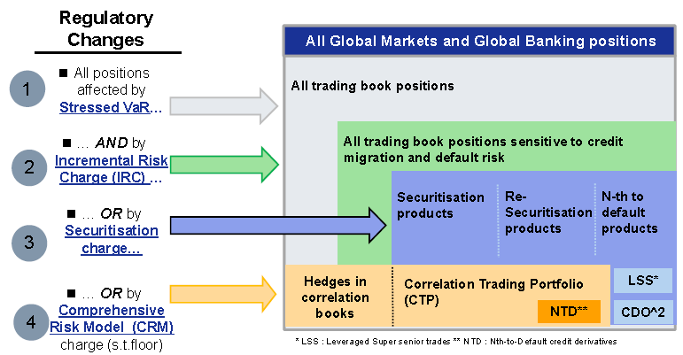

#### Metrics to calculate regulatory capital for market risks

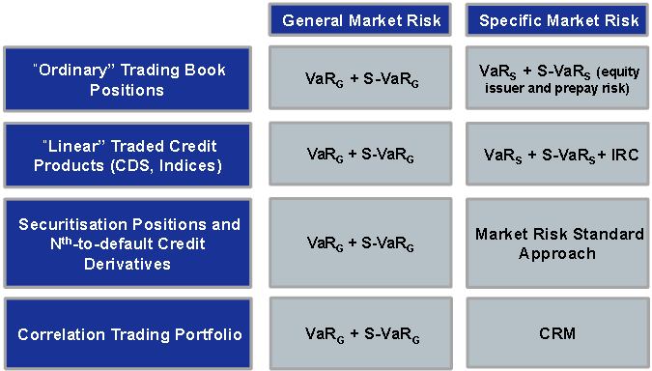

##### IRC Tactical

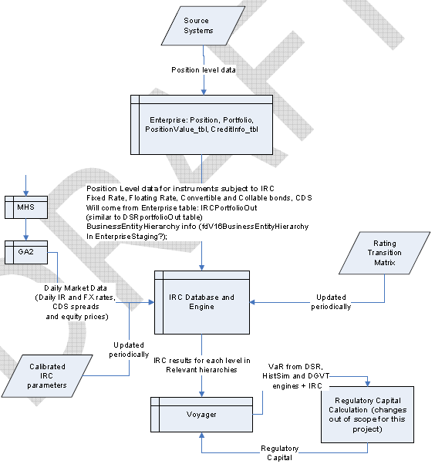

❶**Engine** calculate ***default risk*** + ***credit migration risk*** that are incremental to risks captured in current VaR ❷**Trade Position Feeds** leverage existing data feeds augmented with extra data elements ❸**Market Data** new feed for CDS spread data ❹**Reporting** Regulatory Capital calculation incorporated with new charge ❺**Hardware** engine to run independently but integrated to existing environment ❻**Operation** improve existing operational procedure to monitor and report

##### Requirements IRC

⓿Track Credit Migration + Defaults of underlying & counterparties ❶**Multiple liquidity horizons** (3 months - 1 year, time to sell/hedge in stressed market) ❷**Cover position** subject to capital charges for specific IR risk ❸**Include/exclude** all listed equity, derivative positions, securitization positions ❹**Impact of correlations/ clustering** between default and migration events (higher capital charge for concentrated portfolio, concentration under stressed conditions) ❺**Exposures on non-netted basis** (excepted long/ short positions on same instrument) ❻**Basis risks** (by product, capital structure, rating, maturity, vintage, payout trigger) ❼Impact of potential risks between **maturity & liquidity horizon**, **default risk**, **impact of optionality** from price changes ❽**Constant level of risk modeling** ❾**Correlation & diversification** between multiple obligors and obligor/ market risk factors ❿**Risk mitigation & netting effects** as required ⬩credit migration risk ⬩credit spread risk ⬩equity price risk ⬩IRC at a 99.9% CI, over a 1 year time horizon ⬩age a portfolio of trades for up to a 1 year period ⬩Re-investment logic at end of liquidity horizons to positions that will mature/roll-off during portfolio aging function

#### Stressed VaR

⓿**What?** Measure VaR due abnormal market behavior during selected time period ❶**Approach** **①**Use existing models with current risk factor levels & current portfolio **②**Substitute [current risk factor volatilities & correlation structure] 🡺 those from historical period with greatest VaR for portfolio **③**For *historical approach* supplement actual historical returns with antithetic returns **④**For *simulation approach* replace marginal & joint risk factor distributions in production 🡺 those inferred from historically stressed period ❷**General Market Risk (GMR)** **①**Based on historical state changes from stressed period, sensitivity-based portfolio valuation & current aggregation structures **②**Augmented by antithetic sampling & risk shocks at individual risk factors **Data**: use data with current systems; require time series of risk factors (interest rates, spreads, prices, implied volatilities, etc.) in order to generate *historical shocks* ❸**Equity Specific Risk (ESR)** **①**Based on decomposition of historical state changes from stressed period into *general* and *specific* components BUT use *static* set of regression indices (instead of *dynamically* assigning indices) to make general market risk comparable from one day to next **②**Use only 2 indices (1 country index + 1 country/ regional sector index) ❹**Debt Specific Risk (DSR)** **①**Use historically sampled spreads to compute spread volatility & default risk **②**Use historical changes in spreads + credit spread sensitivities to construct P&L distributions during stressed periods Data (current) historical market spreads (total spread of basket of bonds) based on time series of bond index spreads + information on total spread for each Credit Group; BUT no historical information on total spread at issuer level (historical data on total spread for basket of bonds, but not for individual bonds)

##### Requirements Stressed VaR

**①**Calculate stressed PVs & greeks using full revaluation **②**Shock tenors instantaneously or over extended periods **③**Shock spread curves instantaneously or over extended periods **④**Simulate dynamic portfolio rebalancing **⑤**Replace designated trades that roll off during stress simulation with new trades per requirements (e.g. delta-hedged portfolios) **⑥**Shock curves via parallel or non-parallel shifts of curves and volatilities **⑦**Create stress scenario from historical market data moves by choosing start/end time

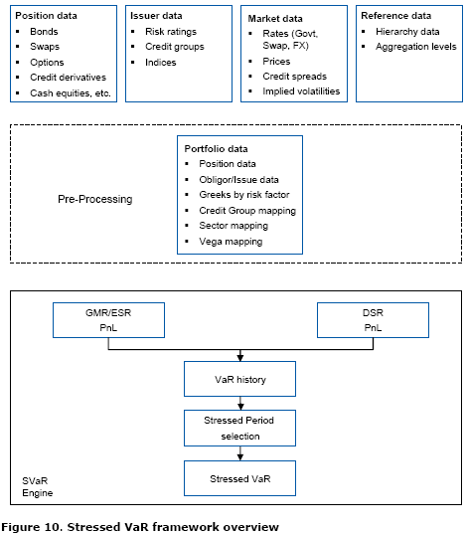

##### Stressed VaR Tactical

❶**Engine** No new engine; DGVRT Parametric Model used as Phase I with calibration applied to stress period’s volatilities ❷**Trade Position Feeds** No new position data is required ❸**Market Data** No new market data required but need to increase the length of the series in database to support “stressed” period selection ❹**Reporting** new report ❺**Hardware** no new hardware ❻**Operation** improve existing operational

#### VaR, IRC, Stress test Performance

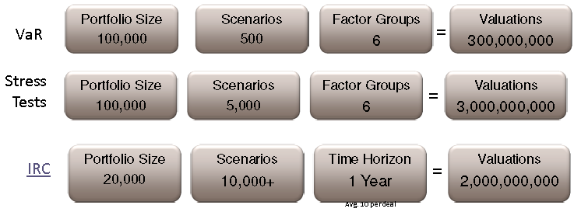

#### Back testing

⓿**What?** Compare theoretical VaR against actual P&L ❶**Basel framework** periodically compares portfolio or asset's daily VaR against daily P&L; model to generate the times of VaR exceeding P&L equal to (1-alpha) * time periods for back testing ❷**Basel 3 zones** **①Green Zone** - 0 to 4 adverse exceptions out of 250 - no add-on factor **②Yellow Zone** - 5 to 9 adverse exceptions out of 250 - add-on factor of from 0.40 to 0.85 **③Red Zone** - 10 or more adverse exceptions out of 250 - add-on factor of 1.00 ❸**Standards** **①Bank level** **aggregate risk** and risk by asset class measured by models used in capital adequacy calculations **②Daily back testing** results at business & desk levels reported to CMRM management & line management; alert to new or unaccounted-for risks; routine quality controls for risk models and systems **③Report adverse SPL exceptions** at bank-level to OSFI within 1 business day **④Monthly analysis of SPL** results submitted to OSFI for review **⑤Backtesting exceptions** and average divergence (average difference between absolute value of SPL & VaR for all adverse exceptions) at bank-level 🡺reported to OSFI quarterly through Basel Capital Adequacy Return schedule 42 **⑥Backtesting comparison** corresponds to structure of VaR limit hierarchy **⑦VaR comparisons** against next day’s changes in static portfolio P&L (SPL results reviewed periodically against actual P&L) **⑧Exceptions at CIBC and business levels** (Tier 1 + Tier 2) validated, explained, documented, reported to senior management ⑨Backtesting results + exceptions available to internal/ external auditors ❹**General Methodology SPL** = P&L due change in market parameters, with positions being held constant - **Valuation methodology** ①Value portfolio using Day 1 market parameter ②Revalue same portfolio using Day 2 market parameters ③SPL = change in portfolio value - **SPL generation process** ①Obtain greeks for Day 1 ②Obtain Day 1 + Day 2 market parameters ③Calculate change in market parameters between Day 1 + Day 2 ④Compute SPL for Day 2 using change in market parameters and greeks ⑤For each individual desk, calculate SPL at greeks level by each appropriate risk factor ❺**Market Risk Methodology** calculate MR SPL by taking Day 1 trading positions, as represented by the greeks, and actual market movements between Day 1 and Day 2. Basic formula based on Taylor series: **SPL = Σ over all instruments [δ* ΔS+ (1/2) Γ* (ΔS)2]+ ν*Δσ+ Θ** where SPL = 1-day change in portfolio value with positions held constant; ΔS = day over day change in price of underlying; δ(delta)/ Γ(gamma) 1st/ 2nd -order marginal sensitivities; ν (vega) = 1st order marginal sensitivity of instrument price to volatility (σ) of price of underlying, Θ (theta) = 1-day change in portfolio, or measure of *time decay*, assuming no change in market prices ❻**Equity Specific Risk** back-tested against portion of SPL related to equity specific moves (market and specific SPL split for given move in price of particular equity, table containing betas for such equity to relevant industry sectors and/or indices generated on a regular basis for DGVRT VaR) ❼**Debt Specific Risk** indirect approach. Formula: **DSR_PL(t+1,t) = Total PL(t+1,t) - GGM_PL(t+1,t)** for each position where Total PL(t+1,t) = total P&L changed = change in mark-to-market price between day t+1 and day t, GGM_PL(t+1,t) = gross general market (GGM) P&L, which includes P&L impact of changes in all underlying market factors. Hence DSR P&L = DSR_PL(t+1,t) consists of P&L components not explained by GGM P&L ❽**Net Trading Related Revenue (NTRR)** excludes “Other” trading revenue (Total trading revenue = NTRR + Other trading revenue), NTRR = trade date based-MTM revenue from trading businesses driven by market movements; components of total trading revenue not included in NTRR: Sales and commission income, Changes to reserves, Changes to valuation adjustments, New business revenue including inception revenue and fees

#### EOD Feed schedule

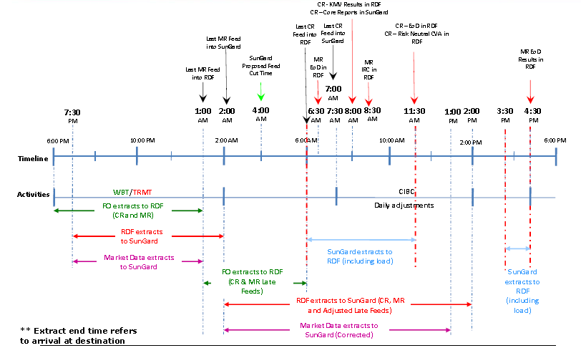

#### Enhanced VaR Tactical

•VaR Calculation tools for new sensitivities (IR Basis, Equity+ Commodity Skew Vega, Dividend, Correlation Sensitivities) •Reporting •Operational Procedures

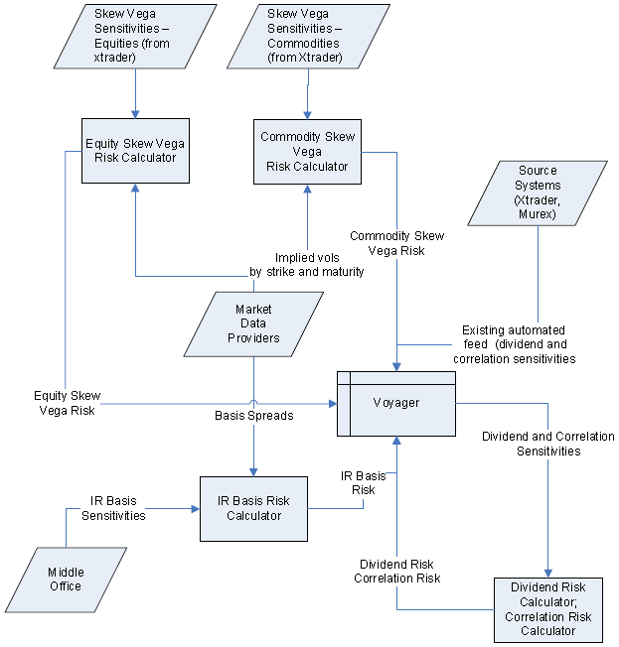

#### IMA (Internal Model Approach) *Documents to be submitted*

➊Market risk policies (describe framework) ➋Organization structure (independence/ segregation of duties) ➌Measurement systems (describe methodologies & models) ➍Stress testing program (selection methodology for scenarios) ➎Back-testing program (previous year’s results, exceptions) ➏Technological environment (diagrams, processes) ➐Limits structure (hierarchical structure, approvals) ➑Management information systems (regular & ad-hoc reports) ➒Databases of relevant information (time series of risk factors, P&L) ➓Reports of independent assessments (internal/ external audit) ➊Estimation regulatory capital (SMM + IMA) ➋Description exposures (by product & risk factor)

## OSFI Initiatives

#### Business Case

❶Develop & implement new **business/ risk framework** including capital models required to meet new IRC and MRA guidelines by OSFI for December 2010 ❷Develop ***Capital Contingency plan*** required by OSFI including ***capital impact assessment*** with consideration to use of multipliers or standardized approach in the worst case scenario that OSFI does not approve CIBC’s IRC and MRA enhancements.

**Project Steering Committee** Liam Mason, Matt Willis, Melody Glover, Greg Frank

**Advisory** Pankaj Agarwal (Finance-Reporting Division) Robert Kowara (Internal Audit) Spiro Daoussis (Risk Management - Credit Risk Analytics) Laurie Russell (Risk Management —RSI Project)

**Overall Project Director (PMO)** Lily Leung

**Work stream Business Lead** ⬩**IRC** Tim Xiao ⬩**MRA/Stressed VaR** Rina Shklyarman ⬩**MRA/Enhanced VaR Measures** Matt Willis ⬩**Securitized Products, Illiquid portfolio** Tim Mills ⬩**Contingency Plan** Michael S Lau ⬩**OSFI Governance** Melody Glover

#### Plan

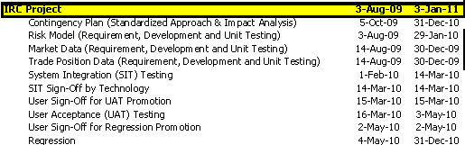

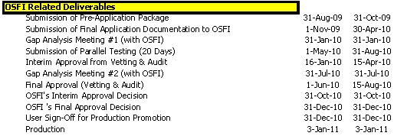

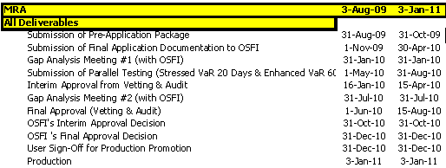

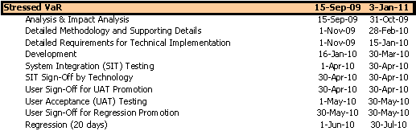

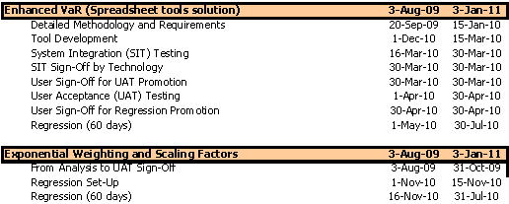

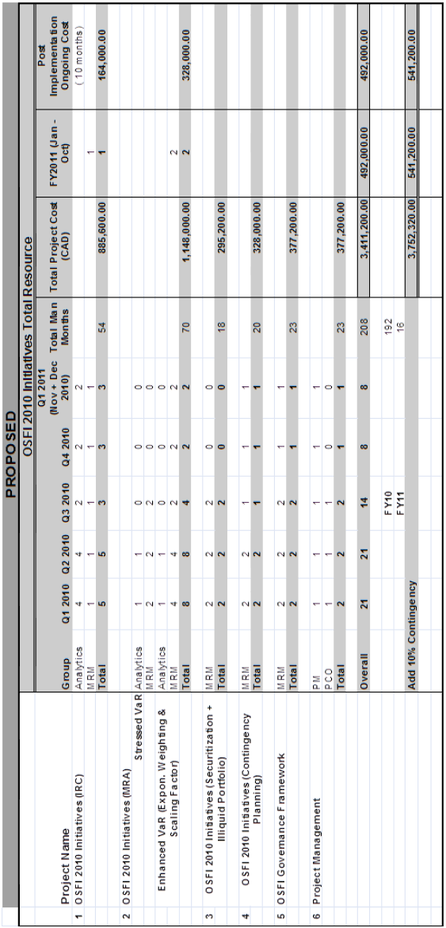

#### Work streams

|  |  |
| --- | --- |
| **Work stream** | **Mandates** |
| **IRC** | Develops/ implements new IRC model & other related initiatives **BCBS guidance for “Guidelines for computing capital for incremental risk in trading book”**, **(IRC) Jul 09** |
| **MRA** | Develops/ implements Stressed VaR, Enhanced VaR, exponential weighting, volatility scaling factor - **BCBS guidance “Revisions to Basel II market risk framework”, (MRA) Jul 09** |
| **Securitized Products, Illiquid Portfolio** | Develops new business/operational framework within Capital Markets, Securitization Work Stream, Chief Accountants to support new capital treatment for securitized product & treatment for illiquid positions (BCBS-MRA guidelines Section VIII) |
| **Contingency Planning** | Develops impact analysis from above initiatives to Senior Management of the Bank and OSFI. Contingency plan should consider standardized and multiplier approach in worst case scenario of non approval for IRC and MRA applications and capital plan work with Capital Management Team that links the contingency plan to the overall capital plan of Bank |
| **OSFI Governance** | Develops/ implements new OSFI compliant framework across project and work streams e.g MIOC approach; completed and resolved self assessment gap analysis. Works with PMO through preparation of all key deliverables into OSFI |

## Credit Risk

#### Requirements

**⬩Methodology framework & Regulatory calculation** based on ➊Basel II AIRB factor based/credit exposure measurement (for parallel run) ➋Monte Carlo Simulation using Internal Models for regulatory approval ⬩**Counterparty Credit Risk Exposure** + **CVA measurement f**or OTC derivatives & Repo-style transactions ⬩**Contingent & Credit exposure** measurement for Repo-Style transactions ⬩**Direct Credit Exposure measurement** ⬩Credit derivative reference assets ⬩Negotiable paper ⬩Certificate of deposits ⬩Fixed deposits ⬩**FX Settlement Risk Exposure measurement** (FX and XCCY Swaps) ⬩Credit Stress Testing & Sensitivity Analysis ⬩Credit Exposure Limits Management & Limit Excess Workflow Management & Limit Excess Reporting ⬩Pre-deal /trade credit limit check & what-if analysis ⬩Counterparty Maintenance ⬩Netting & Collateral Agreements ⬩Document Management & Tracking ⬩Regulatory, Management / Credit Economic Capital Measurement & comprehensive Reporting ⬩**Wrong Way Exposure** & risk measurement ⬩**Portfolio Analysis** in production ⬩**Security Administration & Audit functionality** ⬩**Ageing/Stale calculations** for Wholesale Banking products & all market and reference data for ⬩OTC derivatives & Repo-style transactions for contingent credit exposure measurement ⬩Fixed Deposits ⬩Negotiable Paper e.g. Credit Derivative reference assets + loans ⬩Collateral pledged/received + pledges to exchanges

#### Credit Risk Use Case

⬩**Simplified credit, market and liquidity risks** High level (p. 3) ⬩**Market data analysis** (Market Data Manager) (p. 7) ⬩**Determine/ calibrate simulation parameters** (p. 9) ⬩**Market data****/** **risk factor** **simulation** (p. 13) ⬩**Bootstrap & calibrate market data** (p. 15) ⬩**Transaction valuation and aging** (batch or real-time) – credit risk (p. 17) ⬩**Transactions/positions data transformation** (p. 19) ⬩**CCISization** (p. 21) ⬩**Adjustment overrides/ deal structures** (p. 23) ⬩**Netting treatment** (p. 25) ⬩**Collateral** **treatment** (incl. closeout) (p. 27) ⬩**Client (party) reference information** (p. 29) ⬩**Adjudication** **and documentation** (p. 31) ⬩**Reference data CIBC hierarchies** (p. 33) ⬩**Calculate accounting measures** (p. 35) ⬩**Aggregation and derived risk measures** (p. 37) ⬩**Reporting and OLAP** (p. 39) ⬩**Limit excess workflow** (p. 41) ⬩**Report limit breaches** (p. 43) ⬩**Pledging/ projection forecasts** (collateral) (p. 45) ⬩**Sensitivity analysis and stress testing** (p. 47) ⬩**Month-end** (p. 49) ⬩**What-If/ Pre-deal check real-time** (p. 51) ⬩**Credit Value Adjustment CVA** (p. 53) ⬩**Power analyst & parameter testing** (p. 57) ⬩**Economic and regulatory capital calculation** (p. 59)

#### Credit Risk Exposure

|  |  |
| --- | --- |
| **SUNGARD ADAPTIV**  ➊Register price factors required by valuation models (FX rate, Interest rate, FX volatility surface)  ➋Price factor models register risk factors used to evolve price factors. Construct correlation matrix of risk factors and calculate decomposition (Cholesky or Eigenvalue) ⇨ **Correlations**  ➌Generate grid of of dates based on the *Base time grid* that has been defined in the calculation definition. With *Dynamic Dates on*, all other significant dates that are required as per deal properties are also included  ➍Generate grid of dates based on *Scenario Time* grid (defined in calculation definition)  **REPEAT** ➎ through ➑  ➎For each scenario, for each given point on the scenario grid dates and for each registered factor, generate uniformly distributed random numbers through the Box‐Muller transformation (using methods available from .net library random class) ⇨ **Random Numbers** | ➏For each scenario date, using decomposition matrix, arrive at projected vector of normalized correlated random numbers ⇨ **Risk Factor Values** – Scenario Grid dates  ➐For each factor type, generate path value based on the underlying risk factor process of the factor model (Log diff, O U, Poisson)⇨ **Risk Factor Paths** – Scenario Grid dates  ➑Path values for scenarios’ risk factor types ready? pricing function triggered at base grid dates and dynamic dates (PV’s). Calculation of price factor values at base grid dates (& dynamic dates) happen as per factor model. Path values will form an input in this calculation. If the time points of base grid date do not coincide with the time points of the scenario grid, interpolated path values are taken  ⇨ **Price Factors** – Base Grid dates and dynamic dates  ⇨ **PV’**s – Base Grid dates and dynamic dates |

#### Credit Risk Terminology

⬩**BLACK-SCHOLES**⬩**Collateral**⬩[**Credit VaR (CVaR)**](#_Credit_VaR_(CVaR)) ⬩**Credit Risk Adjudication** ⬩**Credit Valuation Adjustment (CVA)** ⬩**Duration** ⬩**DV01** ⬩**Economic capital**⬩**Interest Rate Risk** ⬩**Monte Carlo** ⬩**Potential Future Exposure PFE**

#### Credit Valuation Adjustment (CVA)

##### Factors influencing CVA

|  |  |
| --- | --- |
|  | ⬩**Definition** CVA = Expected (average) credit loss from c/p transactions = Expected exposure (mean of distribution of evolution of mark to markets) 🞩 Counterparty default probability 🞩 “loss given default”  ⬩**Accounting adjustment** ⇨ fair value, marked to market, accounting for potential counterparty default ⬩**Credit pricing** ⇨ credit risk fairly priced/ compensated ⇨ measured with *Risk Adjusted Return on Capital (RAROC):* originators meet RAROC hurdle then remain “owners” of credit risk |

⇨ Evolution of credit pricing: internal transfer pricing to transfer credit risk into a central function and the originating desks pay “insurance” to divest themselves of this risk ⇨ complex measurement methodologies, infrastructure, politics ⇨ CVA function with own P&L, collects premiums from originating desks in return for indemnification ⇨ front office focus on risks affecting P&L ⬩**Hedging P&L volatility** ⇨ active CVA management into trading positions ⇨ CVA charge for volatile market spreads (Citigroup’s 2009 Q4 included $1.9 billion correction to CVA versus earnings of $3.5 billion) ⬩**Active counterparty risk management** ⇨ hedge counterparty risk to reduce P&L volatility and permit business with specific names ⬩Management of regulatory capital ⇨ reduce regulatory capital if c/p exposure hedged (Basel IIII double default formula)

##### CVA modeling issues

⬩**Expected Positive Exposure (EPE)** vs *Potential Future Exposure (PFE)*, used for limit control purposes and measured to higher confidence level (95%, 97.5% or 99%); CVA for accounting adjustment ⇨ “mark to market plus add-on”; CVA actively traded ⇨ Monte Carlo methodology; Use real world (historical) simulation for PFE but risk neutral (market implied) for CVA ⇨ different models between PFE and CVA or calibrated differently ⬩**Default scenarios** (simple) multiply EPE by static Probability of Default (PD ) and Loss Given Default (LGD ) (complex) correlate PD with market risk factors for simulation ⬩**CVA sensitivities** IR , FX, Credit deltas, gammas and cross-gammas (2nd derivative; for option on S_1 and S_2, cross gamma) ⬩**Wrong way risk** (risk for transaction exposure and counterparty default be positively correlated); counterparty risk increases if positive correlation (at time of default, MTM of counterparty’s portfolio >> average value); wrong way risk difficult to model because requires correlations between default probability and transaction MTM ⬩**Unilateral or bilateral basis** *unilateral CVA* accounts for bank’s exposure to its counterparties; *bilateral calculation* includes counterparty’s exposure on the bank

##### CVA Data requirements

⬩**Market data** •Name-specific credit spread curves – Spot Spread and 90-Day Average Spread •Average credit spread curves by rating – Spot Spread and 90-Day Average Spread ⬩**Reference Data** •LGD by facility External (S&P) • Rating mapped to internal rating (with mapping rules) ⬩**Input Data Processing** •Credit spread curves from market data +LGD ⇨ bootstrap PD (probability of default) using risk-neutral measures to calculate CVA. Use average spread curve if name-specific curve is missing for 1 counterparty ⬩**Overrides** •PD overrides •LGD overrides •Name-specific credit spread curves overrides, e.g., +50bps for all or selected tenors •Average spread curves overrides, e.g., +50bps for all or selected tenors •Rating mapping overrides, e.g., re-map one name specific spread curve (Rogers A) to another average spread curve (Averaging BBB)

##### CVA Calculation Process

###### CVA dependent process

➊Pre-deal Check ➋What-if Analysis ➌Intra-day Incremental (real time feeds) ➍EOD Batch process ➎Month-end process ➏Stress Testing process (Daily, Weekly, Monthly)

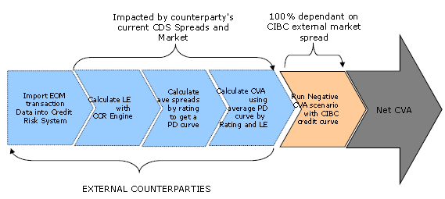

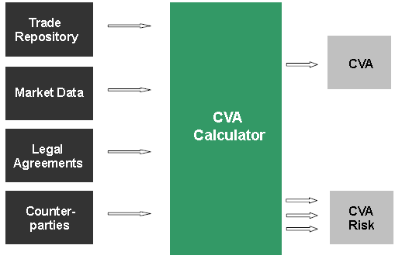

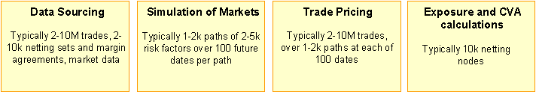

##### Bi-lateral CVA and Net CVA-dependent process

•Intra-day Incremental for real time feeds •End-of-Day Batch process •Month-end process

•Stress Testing process (Daily/Weekly/Monthly)

###### Negative/positive CVA

•If Bank A faces more credit risk than Counterparty B, CVA is **negative** (i.e. it reduces the value of the OTC derivatives from the perspective of Bank A) •If Bank A faces less credit risk than Counterparty B, CVA is **positive** (i.e. it increases the value of the derivatives from the perspective of A) •If present values of the credit risks are same, CVA = **zero**

##### CVA versus IRC

•**CVA** is for OTC credit risk measurement •**IRC** for capital charge calculation •**CVA** accounts for change in net exposure of A to B = EASA-EBSB, where EA=net exposure of B to A, SA=mean loss rate of A (EL*PD)= credit risk of A or B potential loss if A defaults. CVA>0, A may risk losing •**IRC** incremental capital charge because VaR does not account for credit events (default and migration)

## CIBC Risk systems

#### Voyager (Market Risk)

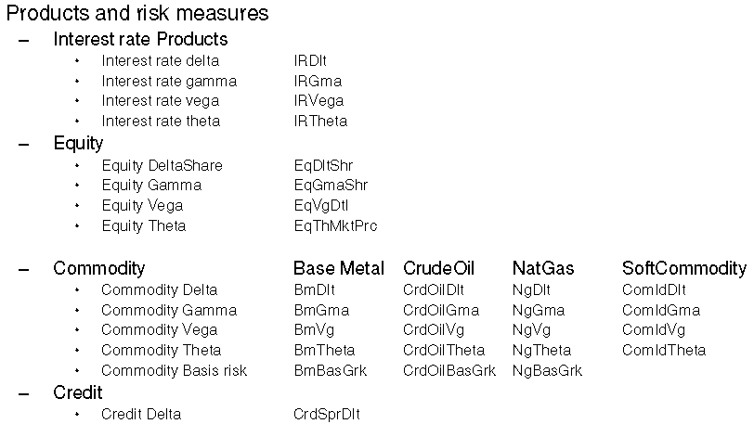

**35 Source Systems/** **300+ source files feed** ➊Store mapped position & GREEK data ➋Store historical data <=13 months ➌Interface with *Enterprises Manual Adjustment* for positional and GREEK data adjustment ➍Provide input for ***Euclid*** engines to calculate delta & gamma ➎Provide input for DSR engine, SPL back testing & final storage ➏Perform zero GREEK transformation ➐2-way interface with TRMT Internal “TRACS” system ➑Consolidated maestro schedule batch job stream with Voyager DW ➒Historical Simulation Process ➓Products & Risk Measures

#### TRACS (Credit Risk)

➊**Multi-dimensional analytics** system with capability to analyze syndication strategy by evaluating complex structured transactions, counterparty risk, industry group and client structure, limits and exposure ➋**TRACS Feed System** .NET Windows service responsible for processing (**80+**) incoming feeds & ensuring correct mapping into main TRACS database ➌**Auxiliary Deal Module (ADM)** deal entry & manual adjustment tool (*Transaction Override Module*, *Deal Level MTM and Security Price Override Module*, *Deal Structures Module*, *Manual Deal Entry Module*) ➍**Availability Inquiry Module (AIM**) to evaluate whether to approve or deny potential deals (➀**Deal approval / denial** based on current risk exposure levels, daily settlement limits, counterparty term limits ➁**Availability Profile reports** for counterparties & deal types ➂**Daily Settlement Limit exposure** profile reports ➃**Counterparty Exposure Summary** reports ➄**Counterparty Deal Detail** reports ➅**Exposure Graphing for counterparty**) ➎**Credit Report Automation (CRA) Credit Stress Engine (CSE**) Calculate *stressed LE* *& MTM of OTC Derivatives, Repo-style, and Credit Derivatives profiles based on PD, LGD, perturbed parameters* ➏**Credit Simulation Module (CSM)** measures sensitivity of counterparty derivative portfolios to small market movements & large market shocks ➐**Exposure Simulation Module (ESM)** determines potential worst-case loss on counterparty’s portfolio ⬩**ESM Batch application** runs market simulations daily ⬩‘**What if**’ scenarios executed anytime ⬩**Calculated values** •Average MTM •Loan Equivalent (or Average Positive MTM) •Credit Equivalent (or 97.5% MTM) ➑**GL Reconciliation Analytical Tool** delta analysis of risk measures across time series & aggregations through drill down of input parameters and deal data ➒**KMV** computes credit risk of economic capital for large corporate loans & expected loan losses (using Moody’s KMV EDF credit measure & Global Correlation Model) ➓**Master Customer Module (MCM)** .NET application to modify counterparty characteristics (e.g., exposure limits, contact information) ➊**Monthly Parameters Update** to update historical data at month start ➋**MTM Difference** interface to examine differences in mark-to-market

##### Systems and Components

|  |  |  |
| --- | --- | --- |
| **System** | **Component** | **Description** |
| **Voyager (24)**  ➊ | Limit Management and Maintenance | Set limits for risk measures (risk and sensitivities) stored in Voyager - on every business entity/risk measure combination and stores limit changes history |
| ➋ | HMT - Hierarchy Maintenance | Create and change hierarchies of business entities and stores hierarchy change history |
| ➌ | Manual adjustments to inputs | Create adjustments for position attributes and sensitivities and store adjustment history |
| ➍ | Sensitivities (Greeks) Calculation (Euclid) | Calculate greeks from position data and market data (supplied by GA2) |
| ➎ | HistSim | Calculate HistSim and DGVT VaR from sensitivities (greeks) inputs for all hierarchies and business entities. The calculation is for different types of risk, generally delta, gamma, vega and overall risk for Equities, Commodities, IR, FX instruments. |
|  | DGVT VaR |  |
|  | Market VaR |  |
| ➏ | Static PL - Market SPL calculation back testing | Calculation of total and decomposed market PL (greek based) |
| ➐ | Odyssey - Market Stress PL Calculation | Calculation of greek based stress PL |
| ➑ | Odyssey Web - Market Stress Scenario maintenance | Create and maintain (update, delete) market stress scenarios by defining shocks to risk factors. |
| ➒ | Stress VaR for Debt Specific Risk | Calculation of DS VaR with stressed input parameters |
| ➓ | VaRTool - Desktop calculation | Calculation of DGVT and HistSim VaR for real or simulated (user defined) portfolios |
|  |  | Functionality to use positional inputs and market inputs from different days |
|  |  | Uses Voyager to get the greek inputs |
| ➊ | VaRTool - Desktop DSVaR tool | Calculation of DSR for real or simulated (user defined) portfolios |
|  |  | Use positional inputs and market parameters from different days |
| ➋ | **RAROC** calculator | Economic capital calculation in Voyager. Used from Chief Accountant's Division |
|  |  | Storage of RAROC historically |
| ➌ | Regulatory Capital calculator | Calculation of regulatory capital associated with General Market and Issuer-Specific Risk |
| ➍ | **BCAR (Basel Capital Adequacy Return)** | Risk Weighted Asset Data for monthly CAD reporting |
| ➎ | Stats | Engine calculated statistic parameters for the different market risk factors by processing their return time series |
| ➏ | Enterprise DB Staging and Enterprise DB | Data Store with Raw data and results. |
| ➐ | MTS Gateway | Delivery mechanism to deliver data from multiple data sources across different system environment. |
| ➑ | OMR Adjustment Tool | End user adjustment tool to adjust OMR Securities Month End positions for RWA – **OMR** (Interest Rate - Asset Backed Security, Collateralized Mortgage Obligations, Mortgage Backed Security, Interest Rate Swap, Loan & Deposits) |
| ➒ | Enterprise Easy Update Tool | Web end user interfaces to perform ad-hoc updates |
| ➓ | Voyager Easy Update Tool | Web end user interfaces to perform ad-hoc updates |
| ➊ | Gemini | Aggregate actual P&L data from DFE. Provides adjustment capabilities and calculates various statistical measures which are then loaded into Voyager |
| ➋ | **MBVaR** | Merchant Banking VaR |
| ➌ | **LTVaR** | Long Term VaR |
| ➍ | Re-Insurance | Atlas |
| **TRACS (13)**  ➊ | MTM and Other TRACS User Interfaces | AIM, MCM, ADM, ESM Console, PEF, FX Web link/dealing, CSE Web App, CSM Web App, MTM Differences, Table Maintenance Tool (TMT) |
| ➋ | TRACS reporting | Reporting environment - databases (daily, weekly, monthly), OLAP cubes and web plus all OLAP cubes (including TAT), web applications and automations (**Credit Report Automation CRA**) – includes report usage logs |
| ➌ | PARAM Process | Monthly parameter calibration databases and all monthly parameter calibration processes |
| ➍ | **Exposure Simulation Module ESM** Engine + ESM Batch Processes | |
| ➎ | **Credit Stress Engine CSE** and all CSE Batch Processes | |
| ➏ | **Credit Simulation Module CSM** Engine, CSM Databases and all CSM Batch Processes | |
| ➐ | Month End Processing and Databases | Month End databases and all month end batch processes for month end regulatory - reporting and economic capital reporting including CVA calculations - |
| ➑ | PEF - Monthly PEF databases and all monthly PEF processes | |
| ➒ | **Table Maintenance Tool TMT** - Functionality/tables that must be maintained | |
| ➓ | MCM Document Scanning and Retrieval | |
| ➊ | TOES functionality | |
| ➋ | Collateral and Pledging Functionality | |
| ➌ | Regulatory Capital Calculation for all trade types | |
| **DVP** | DVP | |
| **LRS** | LRS | |
| **MHS** | **Market History Store** Proprietary data warehouse, previously vendor-based and is now developed and owned in-house by **Corporate, Treasury, & Risk Management Technology (CTRM Technology)** | For input to **Value at Risk (VaR)** engines, receives @ close of business, market, related data via shared **File Central;** capture directly from internal databases + external data vendor FTP sites. **Feed schedules** managed via **SQL Agent**. "Value-added" process data quality assessment, data correction, calculation of derived values MHS supplies accurate, current data to a variety of clients, including internal clients, bank computer systems, and business units. **Trading Room Risk Measurement, Monitoring and Control (TRMC)** - primary users and reviewers of data and access MHS via a customized Excel interface. Spreadsheets programmed in Visual Basic and use ODBC to read and write to the MHS databases. **Business Solution Monitoring Control (BSMC)** secondary users access copy of data, downloaded nightly from the MHS database. BSMC (Ranger) users access MHS via an Excel plug-in. |
| **CIBC Mellon** | CIBC MELLON | |

#### CIBC 5 Asset Classes by 29 Systems

**5 asset classes** = Commodity, Credit Spread, Equity, Foreign Exchange, Interest Rate

|  |  |  |
| --- | --- | --- |
| **System** | **Asset**  **Class** | **Instrument** |
|
| **WSS** | **Foreign Exchange** | FX Contract |
| **Interest Rate** | Money Market |
| **XTRADER** | **Commodity** | Commodity Option |
| **Equity** | American Equity Option, Equities, Equity Swap, European Equity Option, Exotic, Listed Equity Future |
| American Equity Option, European Equity Option, Exotic |
| Equities, Equity Basket, Equity Forward, Equity Option, Equity Swap, Fixed Income Buyback, Foreign Exchange Future, Listed Equity Future |
| Equity Cliquet Option - Equity Option - Exotic |
| **Foreign Exchange** | Commodity Future, Commodity Option, Equities, Equity Basket, Equity Forward, Equity Option, Equity Swap, Fixed Income Buyback, Foreign Exchange Forward, Foreign Exchange Future, Foreign Exchange Option, FX Barrier Option, FX Digital Option, Interest Rate |
| Commodity Option, Equity Basket, Equity Option, Fixed Income Buyback, Foreign Exchange Option, FX Barrier Option, FX Digital Option, Interest Rate Option, Interest Rate Swap, Listed Equity Future |
| Foreign Exchange Option |
| **Interest Rate** | Commodity Future, Commodity Option, Equities, Equity Basket, Equity Forward, Equity Option, Equity Swap, Fixed Income Buyback, Foreign Exchange Forward, Foreign Exchange Option, FX Barrier Option, FX Digital Option, Interest Rate Future - Generic, Interest |
| Fixed Income Buyback, Interest Rate Option, Interest Rate Swap, Single Currency Swaption |
| Interest Rate Option |
| **Commodities** | Agriculture - Base Metal - Crude oil - Commodity Index – FX - Interest Rate – Livestock - Natural Gas - Precious Metals - Soft Commodities |
| **OPTEX** | **Credit Spread** | Debenture |
| **Interest Rate** | Annuity, Asset Backed Security, Bankers Acceptance, Bond, Bond Future, Bond Repo/Reverse Repo, Caps, Deposit, Euro Bond Repo, Floating Rate Notes, Foreign Exchange Forward, Foreign Exchange Swap, Forward Rate Agreements, Futures, Interest Rate, Interest Rate Swap |
| Option on Interest Rate Swap, Single Currency Swaption |
| **DSTS** | **Interest Rate** | Asset Backed Security, Bankers Acceptance, Bond, Bond Residual, Coupon, Discount Note, Floating Rate Notes, GICs, Mortgage Backed Security, Notes, Treasury Bill |
| **ADP** | **Equity** | Equities |
| **Interest Rate** | Equities |
| **ACBS** | **Interest Rate** | Loan |
| **OPICS Barbados** | **Interest Rate** | Bond, Certificate of Deposit, Commercial Paper, Foreign Exchange Forward, Loan & Deposits, Treasury Bill |
| **Foreign Exchange** | Bond, Certificate of Deposit, Commercial Paper, Foreign Exchange Forward, Loan & Deposits, Treasury Bill |
| **ROLFE & NOLAN** | **Interest Rate** | Bond Future, Interest Rate Future |
| **DVP** | **Interest Rate** | GICs, Loan & Deposits, Loan, Mortgage Backed Security, VarMtg |
| **LOANET** | **Interest Rate** | Loan Borrow/Lend |
| **OMR** | **Interest Rate** | Asset Backed Security, Collateralized Mortgage Obligations, Mortgage Backed Security, Interest Rate Swap, Loan & Deposits |
| **GLOBAL ONE** | **Interest Rate** | Loan Borrow/Lend |
| **OPICs Repo** | **Interest Rate** | Bond Repo/Reverse Repo |
| **MBS** | **Credit Spread** | Bond, Commercial Paper Interest Bearing, GICs, Mortgage Backed Security |
| **Bloomberg** | **Interest Rate** | Bankers Acceptance, Bond Residual, Floating Rate Notes, Notes, Treasury Bill, Bond Repo/Reverse Repo, Cash, Loan |
| **MIDAS** | **Interest Rate** | Bond, Loan & Deposits, Treasury Bill |
| **CMI** | **Interest Rate** | Fixed Rate Mortgage |
| **Calypso** | **Interest Rate** | Credit Swap |
| **Quantifi** | **Interest Rate** | Synthetic CDO |
| **Impact** | **Interest Rate** | Bond – Note – T-Bill Repo/Reverse Repo |
| **COBSCO** | **Interest Rate** | Loan & Deposits |
| **Casea** | **Equity** | CFD, Equities, Foreign Exchange, Futures, Listed Equity Option, Mutual Funds, Preferred Shares, Restricted Stock - RSTK, Equities |
| **MANADJ** | **Credit Spread** | Bond, Notes |
|
| **FUSION** | **Credit Spread** | Treasury Bill |
| **Foreign Exchange** | Foreign Exchange, Foreign Exchange, Foreign Exchange Forward |
| **Interest Rate** | Foreign Exchange Forward, Foreign Exchange Swap, Loan & Deposits, Treasury Bill |
| **GRD** | **Credit Spread** | Bond, Credit Swap, Floating Rate Notes, Money Market, Preferred Shares |
| **Equity** | CFD, Equities, Foreign Exchange, Futures, Listed Equity Option, Mutual Funds, Preferred Shares, Restricted Stock - RSTK, Equities |
| **Interest Rate** | CFD, Equities, Foreign Exchange, Futures, Listed Equity Option, Mutual Funds, Preferred Shares, Restricted Stock - RSTK, Preferred Shares |
| **GRID** | **Foreign Exchange** | Foreign Exchange Option |
| **Interest Rate** | Unmapped Instrument |
| **IBTSS** | **Credit Spread** | Loan & Deposits |
| **Interest Rate** | Loan & Deposits |
| **MUREX** | **Credit Spread** | Bond, Bond Future, Call account, Certificate of Deposit, Floating Rate Notes, Interest Rate Future, Loan & Deposits, Treasury Bill |
| **Interest Rate** | Bond, Bond Future, Call account, Certificate of Deposit, Floating Rate Notes, Interest Rate Future, Loan & Deposits, Treasury Bill |
| Bond, Bond Future, Certificate of Deposit, Floating Rate Notes, Loan & Deposits, Treasury Bill |
| Bond, Call account, Certificate of Deposit, Floating Rate Notes, Loan & Deposits, Treasury Bill |
| **FTS** | **Foreign Exchange** | Foreign Exchange, Foreign Exchange, Foreign Exchange Forward |
| **Interest Rate** | Foreign Exchange |

#### SUNGARD

##### SUNGARD services

➊Late feeds ➋Interrupted file transfer ➌Data integrity (uploaded data) ➍Outage caused by change/ network

##### SUNGARD Contract terminology

“**Active Deal**” = Single trade record in the Adaptiv Credit Risk database where such record is subject to evaluation or aggregation processing for the purpose of credit exposure calculations as specified in the FRS. Such exposure calculations include but are not limited to: potential future exposure (PFE), settlement risk and issuer risk “**Adaptiv Credit Risk**” or “**ACR**” = Standard Software module (including any updates thereto) of the ASP Services providing global credit exposure data aggregation and management, credit limit management and related functions “**AdaptivTrack**” = SunGard Incident Management System “**Band**” = tier of Transaction volumes and associated Transaction Fees as set out in Section 3.5 to Part F of this Schedule 2 “**Billable Dealing Transaction**” = deal entry, deal modify or deal reversal activity recorded in ACR where such activity triggers a portfolio exposure update as part of the Transaction. For the avoidance of doubt, pre-deal checks, mark-to-market updates or any other end user activity are generally not considered Billable Dealing Transactions “**Downtime**” = time period in which the ASP Services were unavailable to process Transactions, as further defined in Section 5 of Part B of this Schedule 2 “**End of Day**” or “**End Of Period**” = overnight batch process sequence as further described in the documents referenced in Section 2.1 of Part A of this Schedule 2; “**Initial Term**” = time period commencing on the Schedule 2 Effective Date and ending on the earlier of: (a) the fifth anniversary date from the date of Adaptiv Credit Risk First Productive Use, plus the number of days between the date of Adaptiv Credit Risk First Productive Use and December 31st in the calendar year into which the date of Adaptiv Credit Risk First Productive Use falls; (b) the date this Schedule 2 is terminated by either

Party in accordance with the terms of this Schedule 2 and the Agreement **Renewal Term**” = each successive three (3) year period after the Initial Term for which this Schedule is renewed in accordance with clause 2.2 of the Agreement “**Risk Carrier**” = special type of Active Deal that stores the exposure profile for a portfolio, representing a system generated container within Adaptiv Credit Risk for an externally generated exposure profile “**Risk Carrier Transaction**” = special type of dealing Transaction impacting a Risk Carrier deal in the ACR database that stores the exposure profiles for a portfolio of other deal contracts, such Transactions being of the add, modify or reverse types “**Standard Software**” = any Release of: Adaptiv Credit Risk Server; including inter alia Web UI (the “Portal”); Core processing server; Real-time interface handler; and Batch interface handler “**UK Business Hours**” = time period between 09:00 a.m. and 17:00 p.m. (UK local time) on any day from Monday to Friday, excluding official UK bank holidays.

##### SUNGARD Modules

| **Adaptiv Component** | **Functional Description** | **Risk Type** |
| --- | --- | --- |
| **Master Data Store (MDS**) | Central repository for all trades, issue and static data. The trades types represented in the MDS correspond with products in the various client Front Office systems. Each modification to the data set is validated and audited. | Market  Credit |
| **Risk Hub** | This is the main application component, hosting the portfolio membership rules, aggregation logic and mapping of the MDS trade format to AA trade format. The following functions are available:  Data Admin Tool:  • Input and maintenance of static data  • Customer mapping  • Input of deal corrections and exposure overrides  • Viewing and acting on exceptions and warnings  Limits and Workflow:  • Setting of term-based exposure limits  • Setting of maturity checks  • Setting of authorised products  • Processing of Excesses and Violations  Exposure Monitoring:  • Viewing of exposures by portfolio  • Pre-deal checks  • What-If analysis  Canned Reports:  • Paper-based reporting | Market  Credit |
| **RiskScape** | Historical exposure database:   * Max deal measure values per business day * 15-point portfolio profiles per business day (Note: Full granularity of profile is available in binary format for interrogation where required. This will be built into specified reports (see for example Credit As-Of in Ref #3), and can be inspected ad-hoc via a SunGard tool | Credit |
| **StressScape** | Database of exposures from automated Credit Risk stress runs:   * Max deal measure values per stress test ID * 15-point portfolio profiles per stress test ID (NOTE: Full granularity of profile is available in binary format for interrogation where required. This will be built into specified reports (see for example Credit As-Of in Ref #3) , and can be inspected ad-hoc via a SunGard tool | Credit |
| **MDS Interface Layer** | This handles all interactions between MDS and CIBC upstream and downstream systems. Functions are:   * Validation of files received * Conversion of files to “delta” operations * Collection and processing of exceptions | Market  Credit |
| **Adaptiv Analytics (AA)** | ⬩**Monte-Carlo (MC) valuation** of applicable trades for market and credit risk based on data with each request. There will be two model sets:   * SunGard AA models value trades in FO systems other than X-Trader * RAF models (built by CIBC) value trades booked in X-Trader   ⬩AA performs for Credit Risk **aggregations** of applicable trades to be passed back to ARH for further aggregation with Factor-based trades.  ⬩**Incremental Monte-Carlo (IMC)** used for real-time exposures MR + CR  ⬩**Analytics for market risk** produces scenario results for:   * VaR * P&L stress tests * Scenario PV values for Historical Simulation by factor group * Scenario PV values for MC market VaR by factor group * No-action P&L * IRC * (DSR) IR and EQ specific risk scenario PV values   ⬩Trade associations to **Risk Factors Analytics Workspace** providing users with ability to what-if or replay analyses. | Market  Credit |
| **Market Data Manager (MDM)** | This is the central repository for all market data, including data for pricing parameters, current market rates, and historical time series. Functions are:   * Volatility correlation statistic sets and MC drivers * Current rates and pricing parameters * Calibration of the data based on the models   MDM will be fed data from upstream; read-only access for users. | Market  Credit |
| **Valuation Input Store (VIS)** | This component stores the history of AA formatted trade data, market/historical data, and calculation parameters passed to AA that were used to calculate the scenario PVs. It acts as the principal source for audit, corrections and reproducibility of scenario PVs collected by the RiskCube. The VIS provides the ability to retrieve the trade/market data for any as-of date, and supports corrections to this data. The VIS supports workflow events that control the process for EoD, trade corrections, market data corrections, and late feed processing. | Market |
| **Adaptiv Risk Cube (ARC)** | This component allows the viewing, calculation and storage of market risk results dynamically aggregated to users’ requested dimension and drilldown to the trade level. ARC receives scenario PV data from AA calculations, and provides drill down slice & dice analysis functionality based on a set of attributes tagged against each trade. These trade tags define the dimensions of the drill down filters. | Market |
| **SWORD** | Monitoring of:   * KRIs * Adaptiv workflows | Operational Risk |

#### MUREX

##### Murex FX Deals

**Spot Trade** settlement/delivery takes place within 1 to 2 business days **Outright/Forward** settlement/delivery takes place on any date other than spot **Swap (+Overnight)** consisting of two parts (Near Leg + Far Leg) **Take Ups (Time Options)** Forward valued trade where the counterparty has the right to trigger delivery of funds between specified date & value date **OIS Overnight Index Swap** overnight rate exchanged for some fixed interest rate **IRS Interest Rate Swap** one party exchanging a stream of interest for another’s party’s stream **DEPO Deposit** counterparty agrees to take on funds at a specified rate **LOAN** counterparty aggress to sell funds at a specified rate **Futures Trade** allows trader to buy or sell specified amount of given currency at specified price on specific date in future

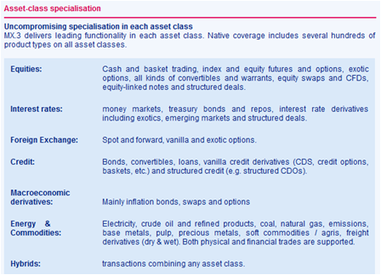

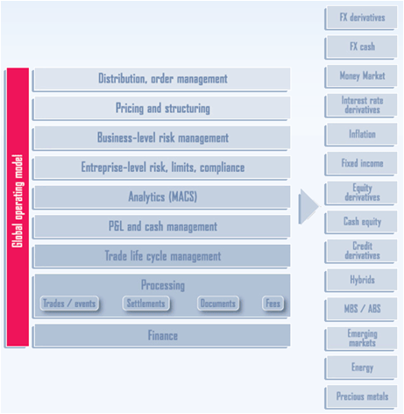

##### FX portfolios

All Spot portfolios will be owned and maintained within their own region. As well, all non-CAD forwards trades will be maintained in their respective portfolios. All CAD forwards will be routed to the Toronto Forward book ‘Darrin Brooker’ from all regions. The FX system will

strip out all forward CAD positions of booked trades to portfolio ‘Darrin Brooker’, regardless of the geographical origin of that trade. Any non-CAD forward positions will remain in the respective trading center. All portfolios will have the capability to input trades in all MurexFX supported products and view their risk on a portfolio basis.

##### MUREX trade flow

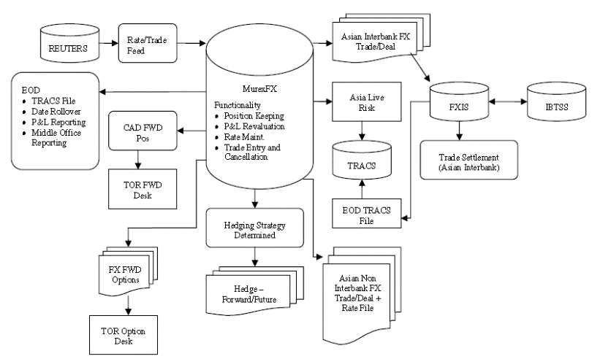

##### Trading system interfaces

**Electronic Broking Systems EBS**'s closest competitor is **Reuters Dealing 3000 Spot Matching**. The decision by an FX trader whether to use EBS or Thomson Reuters Matching is driven largely by currency pair. In practice, EBS is the primary trading venue for EUR/USD, USD/JPY, EUR/JPY, USD/CHF and EUR/CHF, and Thomson Reuters Matching is the primary trading venue for commonwealth (AUD/USD, NZD/USD, USD/CAD) and emerging market currency pairs.

##### P&L Calculation

Deal’s 4 components ➊Exchange Rate ➋Base Rate ➌Spread & Discounts ➍Amounts Consider EUR/JPY trade for $1M buying EUR, exchange= 161.5257 ( -0.015 discount), base rate= 1.358677 EUR/USD (0.000056 discount), spread of 0.002 (on the EUR rate) **JPY amounts** = $1M * 161.527 (Exch. Rate) = 161,527,000.00; **USD/JPY forward rate** = 118.8855504 (Exch. Rate / Base Rate) + **spot rate** = 118.87050406 (Exch. Rate + Exch. Discount); **EUR/USD forward rate** = 1.360677 (Base Rate + Spread) + **spot rate** = 1.360621 (Base Rate + Spread – Base Discount) ⇨ spread P&L generated on this trade 2000 EUR (EUR/USD Forward Rate * 1M – (Base Rate * 1M)) ⇨ 1472.02 USD IN P&L

## Risk IT Architecture

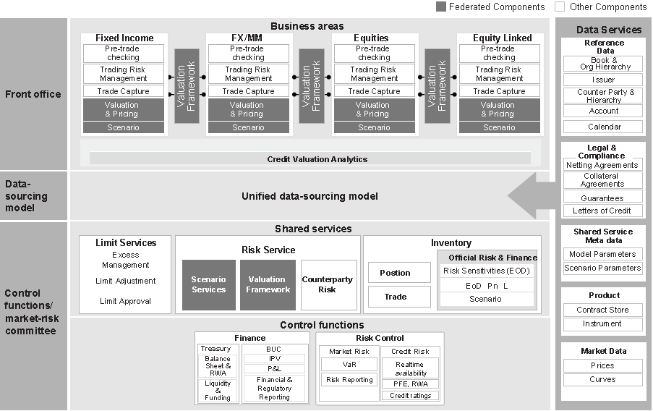

Federated Architecture (FA) = pattern in enterprise architecture that allows interoperability and information sharing between semi-autonomous de-centrally organized lines of business (LOBs), information technology systems and applications

##### On Risk Data architecture

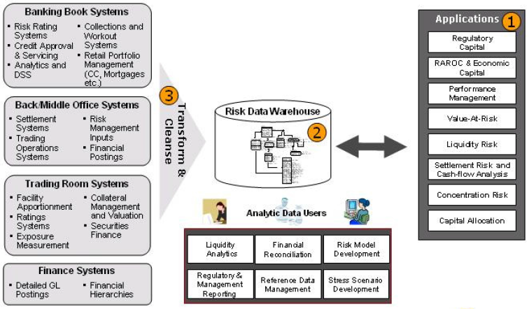

➊**Data Processing applications** extract-and-process ❷**Analytic Repository** simple reporting to complex ad-hoc queries, usually a confusing mish-mash of different systems ❸ **Data Cleansing and Transformation** from flat files, real-time data from data bus, data quality issues, snapshot data vs. changes - large volumes with imperfections in data

## Risk Data Management

##### On Financial Risk Data Requirements

➊**Detail** rather than aggregate data but detailed transactional and position data for on-request/ situational ad-hoc aggregates ➋**Complete** 100% coverage of all positions of the firm instead of only notional size of a position ➌**Timely** analysis to keep up with rapidly moving markets ➍**Integrity** correct data

##### Risk Data Management Best Practices

**Bank in essence** = IT Company ❶Software manufacturing ❷Data production & consumption ❸Information supply chain **How to manage business view of data**? ❶Language interface business to IT ❷Conceptual model

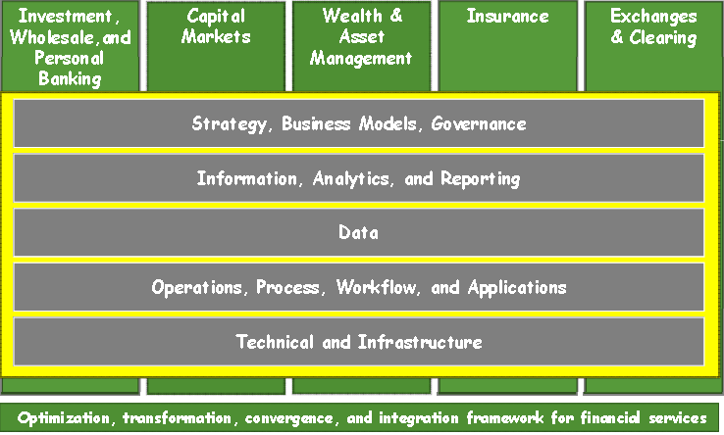

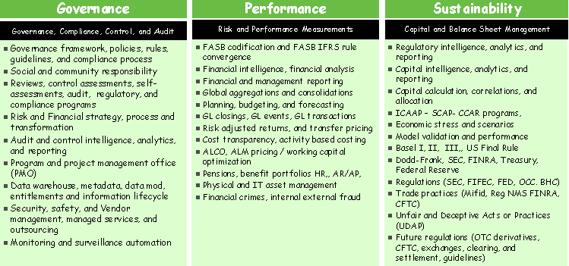

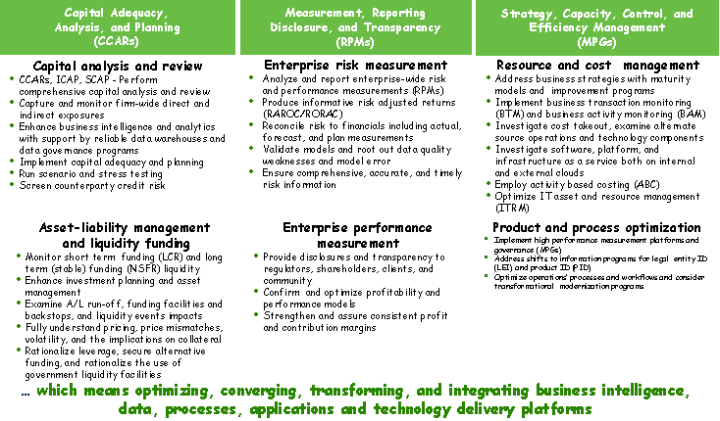

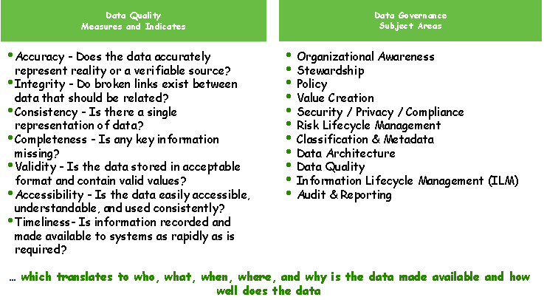

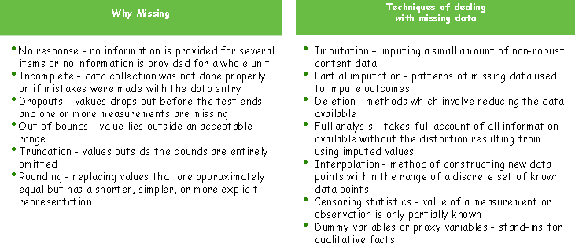

##### Investment Platform

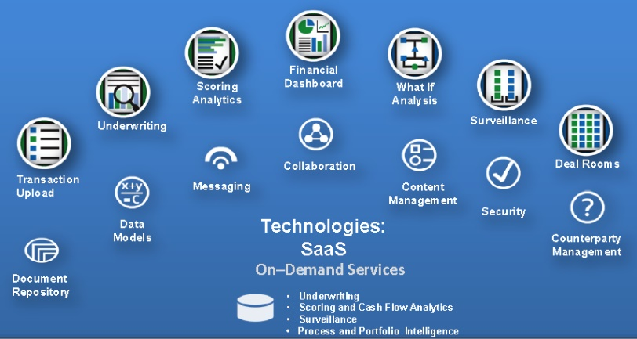

##### Data standards in process chain

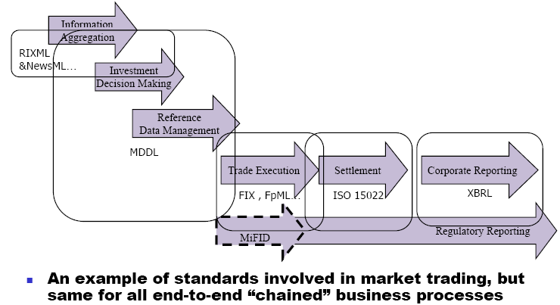

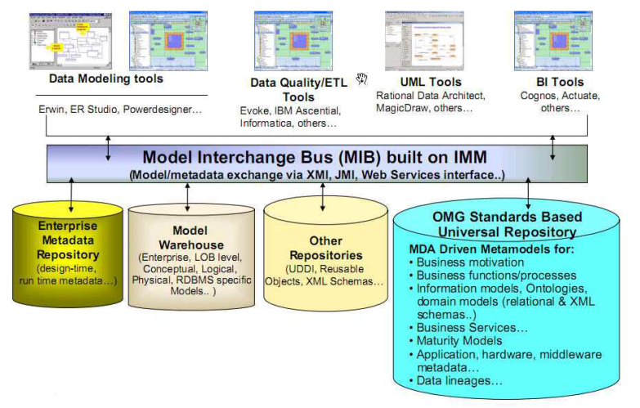

# Financial Risk Topics

## Stress testing framework

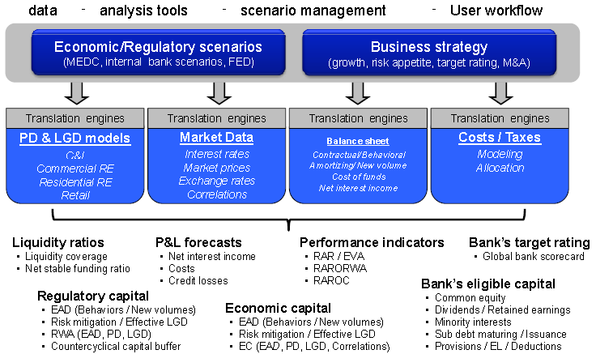

#### Risk appetite

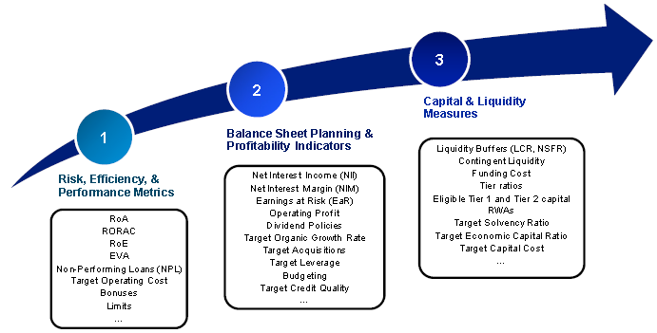



## Liquidity Risk

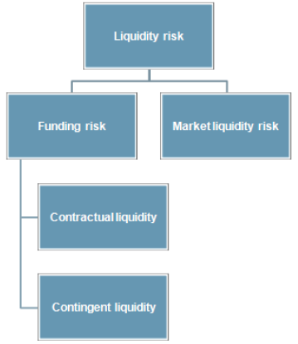

#### Overview

**⬩Contractual liquidity** assessment of all material, known/ expected cash flows from existing contracts under normal/ stressed market conditions ⬩**Contingent liquidity** assessment of all expected cash flows taking into account customer behavior (prepayments, rollovers, draw down of credit lines, recoveries) under normal + stressed markets ⬩**Market liquidity risk** assessment of market liquidity + credit spreads under normal and stressed market

#### Cash flow landscape

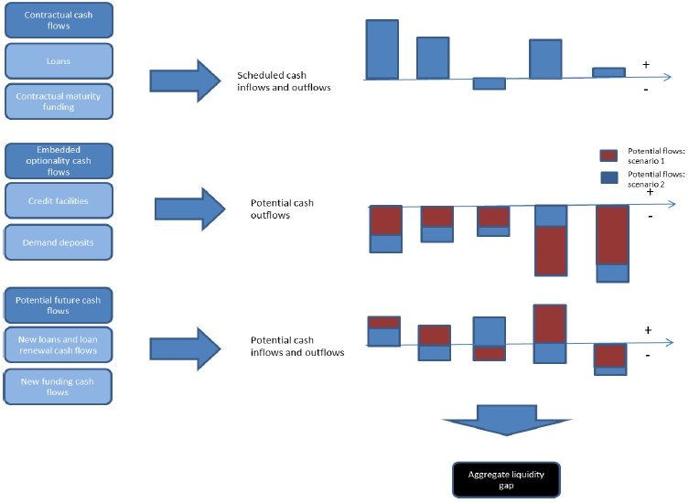

#### Fund transfer pricing with liquidity risk

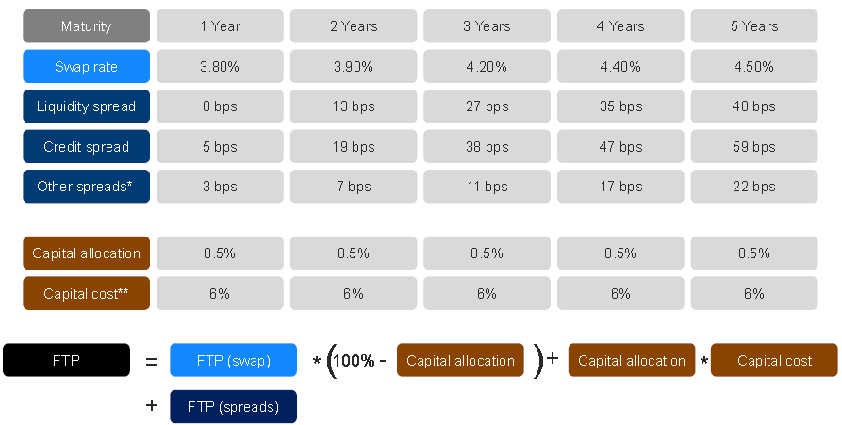

#### Contingent liquidity pricing for a facility

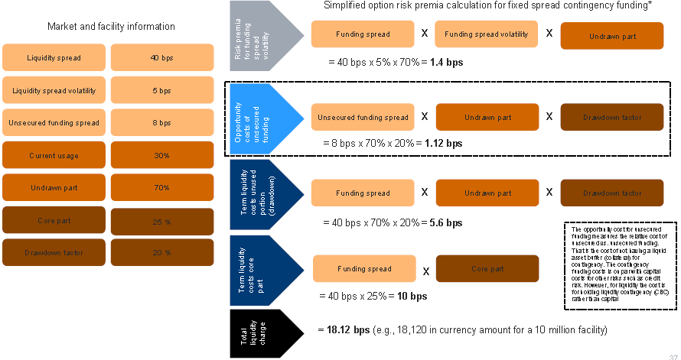

#### Contingent Cash Flow Funding Risk (CCFR) for derivatives

⬩**CCFR**=method to determine the market value of cost of funding of assets and liabilities; applies to all trades and positions including retail assets and liabilities ⬩**Liquidity funding risk (LFR)** leverages Market and Credit Risk data feeds; retail feeds leverage off the current Liquidity Risk System (LRS) feeds ⬩**CCFR sources** = GIC'S, VISA, bank account,

RRSP, wholesale automobile loans, mortgages, student loans, commercial loans

## Non-trading risk

#### WESTPAC Definition

⬩**Non-traded market risk (interest rate risk in banking book)**= risk to interest income generated by a mismatch in the duration of the assets and liabilities (Treasury’s responsibility) ⬩**Equity underwriting & warehousing risk** 🞈*Equity underwriting=* development of solutions for corporate and institutional customers with demand for equity capital 🞈*Equity warehousing*= acquisition of assets in anticipation of refinance through combination of senior, mezzanine and capital market debt and listed, unlisted and privately placed equity; unlike *underwriting risk*, bank is principal owner from acquisition until sale 🞈Managing equity underwriting & warehousing risk ⇨ evidence of expected equity investor/ debt financier interest ⬩**Operational risk** from inadequate or failed internal processes, people and systems or from external events ⬩**Liquidity risk** potential inability to meet payment obligations (responsibility of Treasury, who monitors funding base & ensures that base prudently maintained & adequately diversified ⬩Compliance risk ⬩Reputation risk

#### Non-Trading Book Exposures in Equities (Lloyds bank)

⬩Wholesale - from transactions in private equity market as result of *debt for equity swaps*, medium term investments held for gain with limited partnership stakes & listed/ unlisted equity shares ⬩**Available-for-Sale financial assets** non-trading debt securities/ equity shares, at fair value through profit/loss, held-to-maturity investments or loans & receivables; recognized in B/S at fair value, inclusive of transaction costs; sold in response to needs for liquidity or changes in interest rates, exchange rates or equity prices; gains/losses recognized in *other comprehensive income*, until the financial asset is either sold, becomes impaired or matures (cumulative gain/loss then recognized in income statement). Interest calculated using effective interest method and FX gains & losses on debt securities denominated in foreign currencies are recognized in income statement; can be transferred to *loans and receivables* or *held-to-maturity* category ⬩**Equity Investments (Including Venture Capital)** unlisted equities and fund investments

## Basel III

#### Overview

##### Financial Institution in Canada

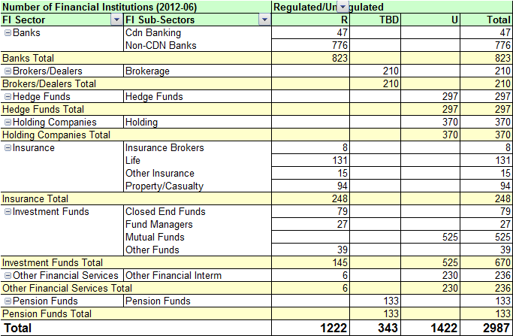

##### Capital reform, Liquidity Standards, Systemic Risk

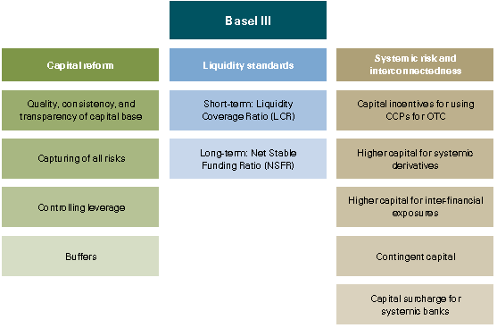

##### Capital under BASEL III

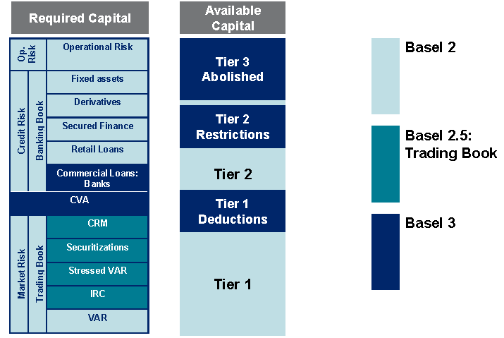

##### Minimum Capital Standard

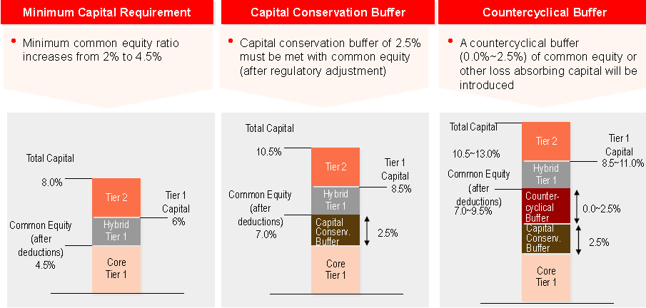

#### Regulatory Objectives

##### 1-Increased quality of capital

##### 2-Increased quantity of capital

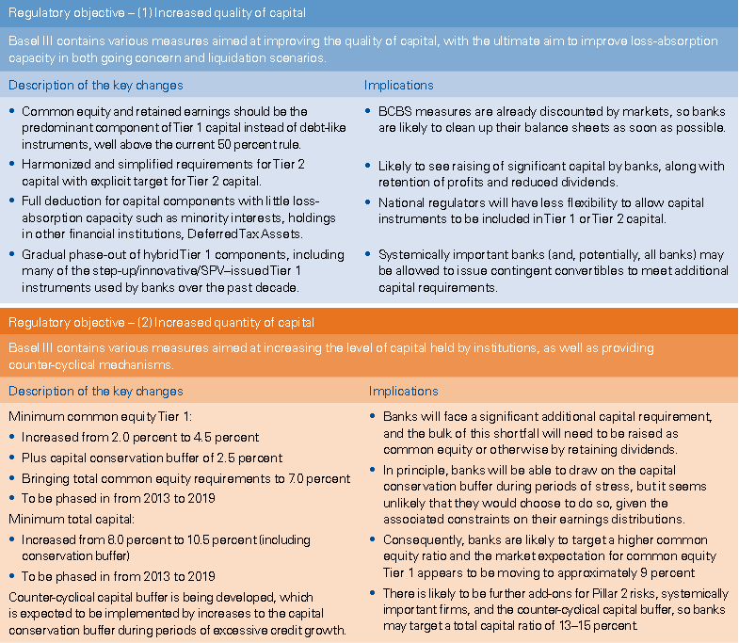

##### 3-Reduced leverage with backstop leverage ratio

##### 4-Increased short-term liquidity coverage

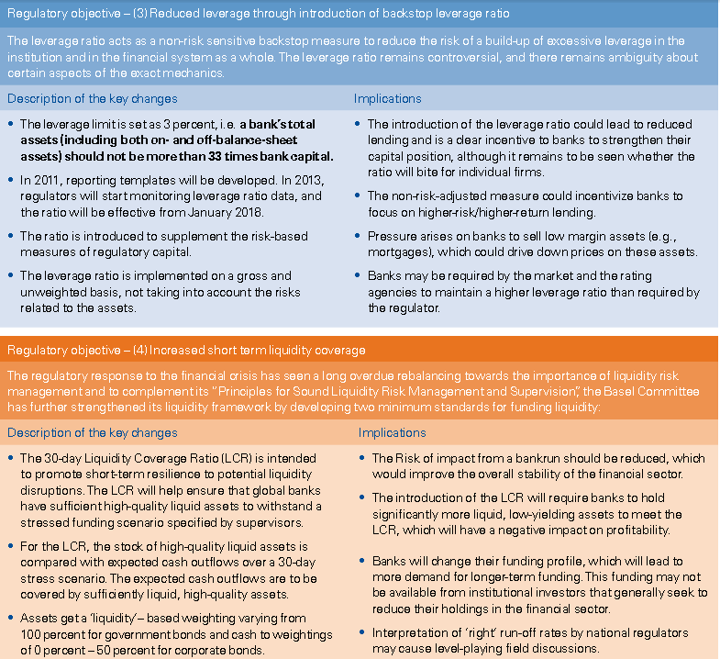

##### 5-Increased stable long-term balance sheet funding

##### 6-Strengthen risk capture notably counterparty risk

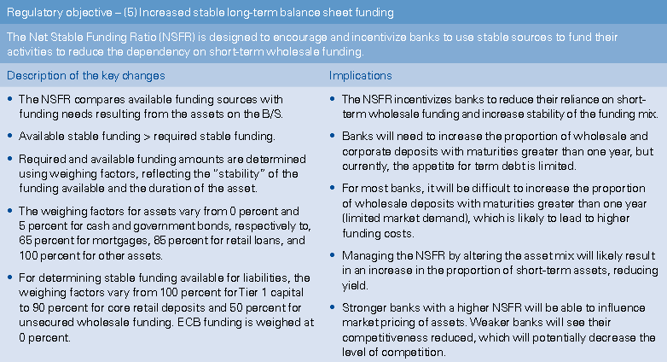

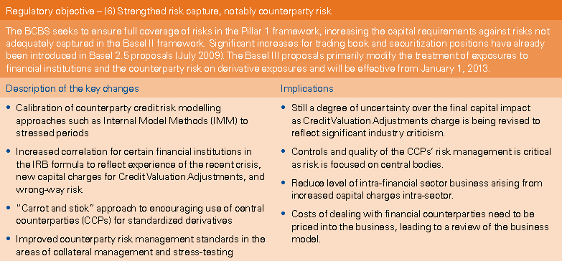

#### Timeline

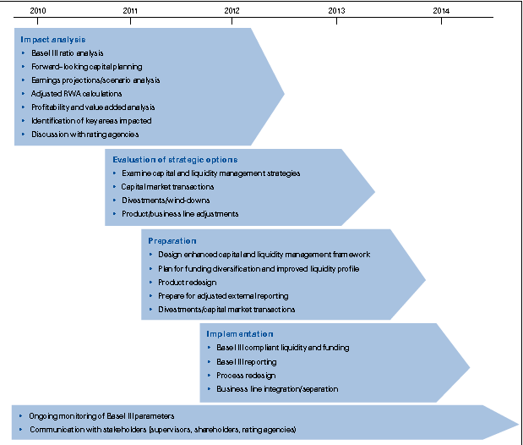

# Enterprise Risk

#### ERM framework

|  |  |
| --- | --- |
|  | • **Strategic Risk Management** enabled by strong governance,  identification, assessment,  management of risks  • **Key tools** include risk appetite,  risk assessments, stress testing, capital management  • **Analysis** uses multiple approaches & lenses (accounting and economic) to  assess risk and reward |

#### Risk Appetite, Assessment, Measurement

|  |  |  |
| --- | --- | --- |
| **RISK APPETITE** | **RISK ASSESSMENT** | **RISK MEASUREMENT** |
| **•Enterprise + business unit risk tolerance, strategy, policy & financial goals**  **• Periodic review, actively**  **engage Board, C-Suite** | • Identify, manage top 10-15 key risks faced by enterprise  • Quarterly review  • Self Assessments  • NPI Process | • Economic Capital  • RAROC  • Stress Testing  • Category specific - Loss  Forecasting, VaR etc.  • Aggregation • Drilldowns |

##### Sample Process Workflow

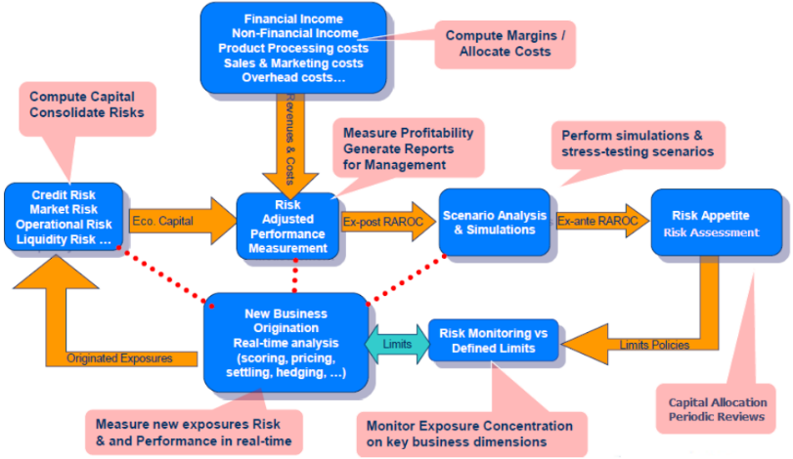

#### Risk Type - Risk Management

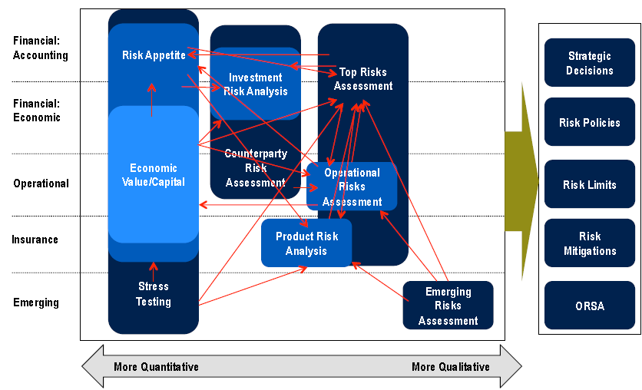

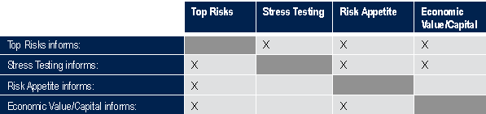

#### Risk Models

A range of risk models is used, each fit for purpose, with reconciliations across platforms to ensure consistency. All models are subject to a single model governance framework

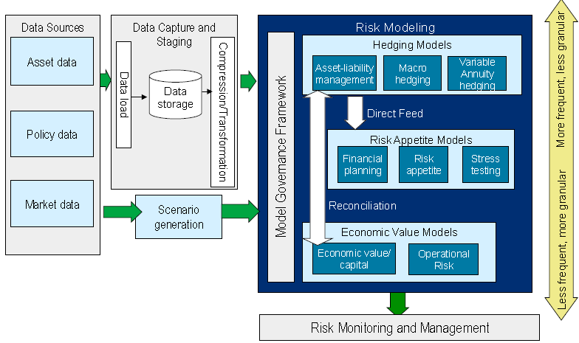

##### Interest Rate Analysis Example

|  |  |
| --- | --- |
| **Framework/ Models** | **Analysis Performed** |
| **Product Risk Analysis** | Regular review of product spread compression to inform in-force  management and new product pricing |
| **Stress Testing** | Used a “zero rates” stress test on projection of future risk based  capital (RBC) over a 30 year period to assess exposure to extended low rates |
| **Risk Appetite** | Quarterly analysis of high and low rate scenarios to assess  impact relative to risk limits – corrective actions taken in the  event early warning signals are breached |
| **Economic Value Model** | Analyzed impact on economic surplus of a 475 basis point rate  shock up and down |

#### Identifying Top Risks

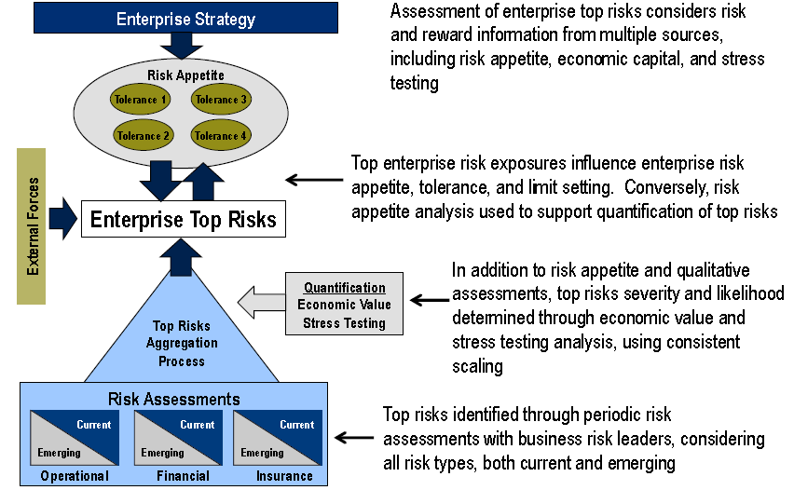

#### 

#### Financial Regulation

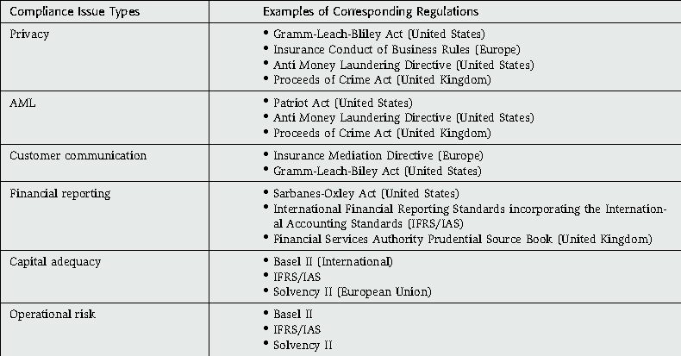

# Operational Risk

## COSO

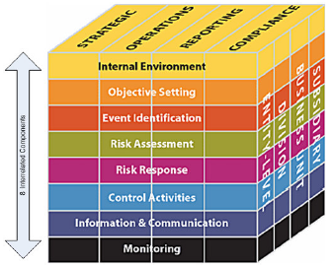

## Operational Risk

#### 4 types of losses

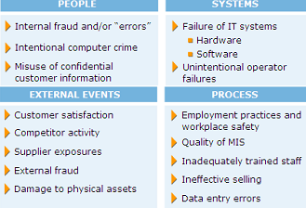

#### BIS Definition

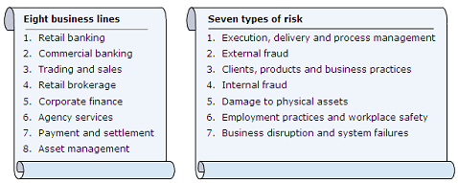

#### Risk Identification, Type, Cause

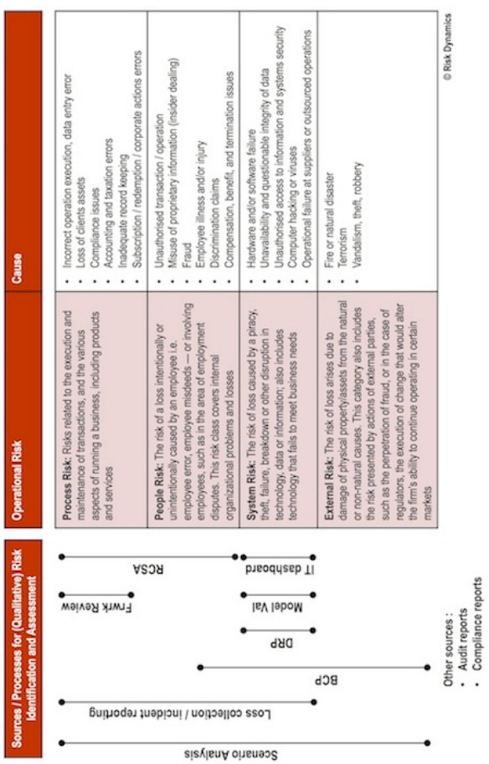

#### Event, Category, Activity

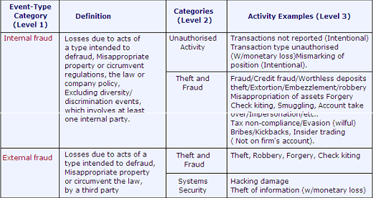

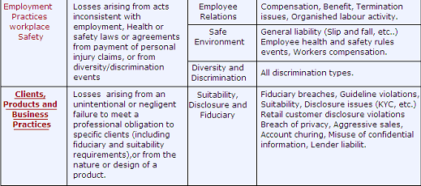

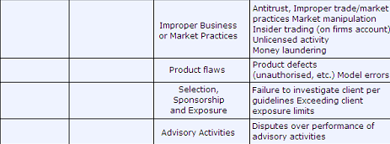

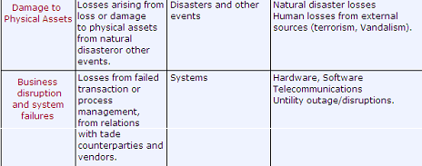

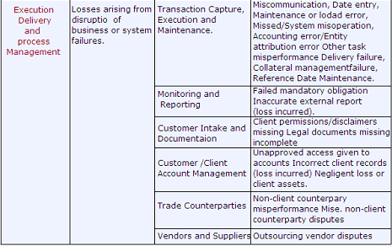

### Assessment Approach

#### 1 Input to Risk Catalogue

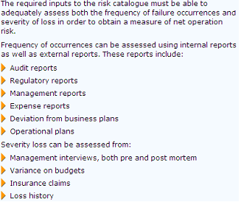

#### 2 Risk Assessment Scorecard

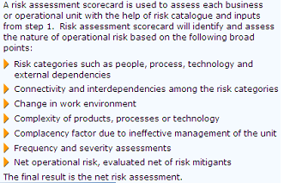

#### 3 Review and Validation

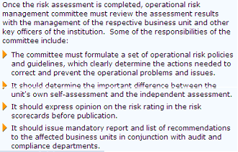

#### Output of assessment process

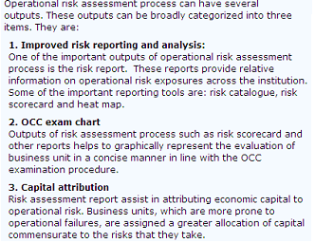

#### OR Tools

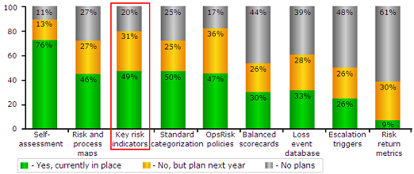

#### OR Management System

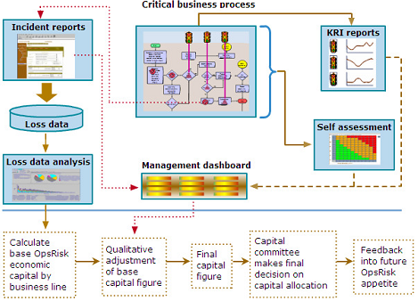

### Operational Risk Management System

#### OR in the context of risk

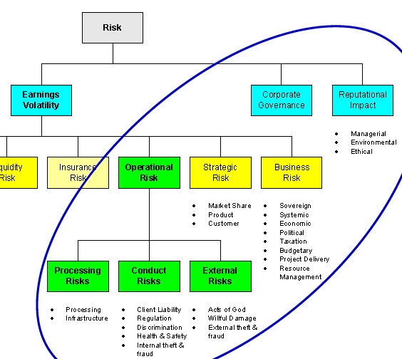

### Key Risk Indicator (KRI)

**Key risk indicators (KRIs)** = measures to signal rising OR or to assess OR exposure

#### 12 KRI

➊**Audit Issue** **Management Index** number + severity audit issues not yet resolved ➋**Business Continuity** **Index** vulnerability & criticality of processes, quality of continuity plans, frequency & adequacy of practices / tests ➌**Failed Customer Interactions Index** number, duration & severity of failures to provide customers with prompt, reliable, effective service ➍**Information Security Index** number & severity of virus attacks, critical vulnerabilities left unresolved for significant period, security events with client impact ➎**Information Technology Index** availability of technology at critical periods for critical purposes ➏**New Product Index** rate of introduction of significant, new products with major implications for people, processes or systems ➐**Operational Losses** dollar amount of losses ➑**Process Breaks Index** rate, severity and size of trading, clearing and settlement failures and customer impact ➒**Profitability Index** number, suddenness and severity of unexpectedly high profits or losses **➓Policy Exceptions Index** number & significance of policy exceptions **➊Regulatory Index** number & severity of comments made and fines levied by bank and regulators ➋**Staff Turnover Index** turnover rates in critical functions

#### Objectives, Strategies, Risks, KRI’s

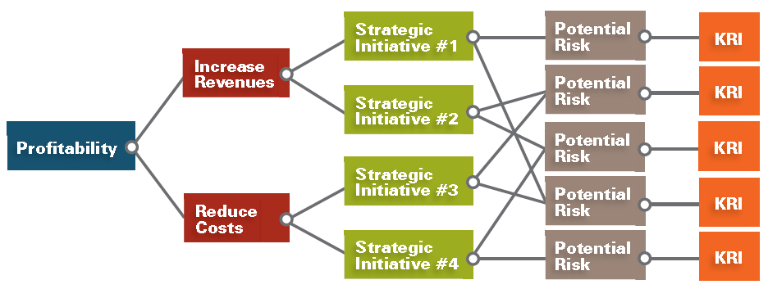

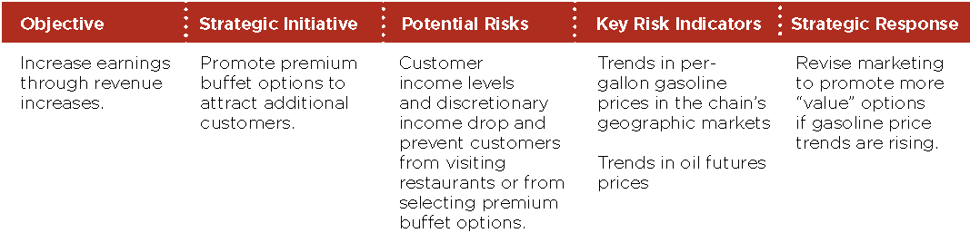

#### KRIs to Inform About Risk of Debt Covenant Default

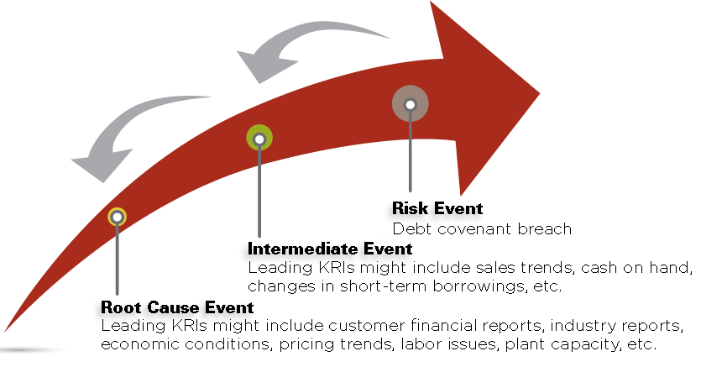

#### KRI for Operational Risk

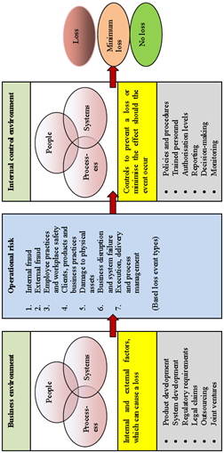

#### Enterprise Risk Management Schematic

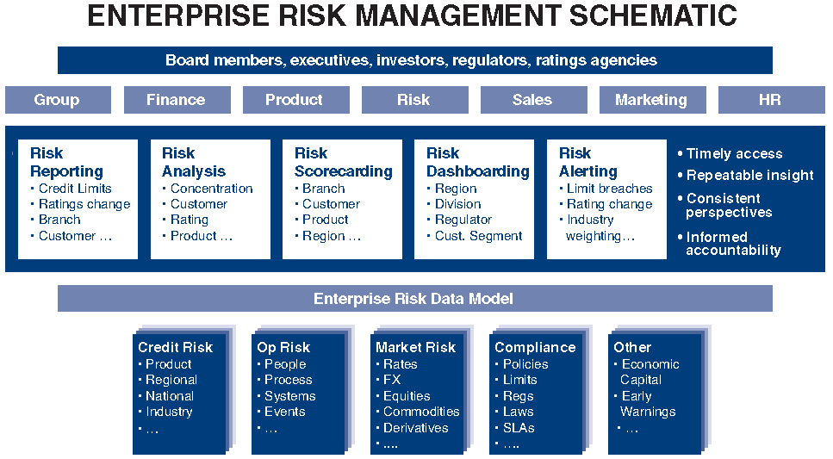

# HOOPP

## Middle office processes

①Financial report ②Origination ③Maturities/ amend ④Reconciliation ⑤Settlement/custody ⑥Valuation

## Collateral Business

•$40B in assets •Security lending + REPO + OTC •Collateral book ~ $20B (pledged, etc) •C/P derivatives 20 SECLEND 10 REPO 12

## Straight-through Processing STP

🕮**SCD STP**

#### Dodd-Frank

❶**Swap Dealers (SDs)**/ **Major Swap Participants (MSPs)** Dodd-Frank ⇨ full set of regulatory requirements (capital, margin, business conduct, etc.) ❷**Financial Users of Swaps** subject to clearing, trade execution, reporting and, if the counterparty is an SD/MSP margin, documentation and other requirements ❸**End-Users** exempt from clearing and trade execution for swaps used for hedging; but proposed margin rules require margin arrangement (although no specified margin amount reporting required) ❹**Central Banks** excluded from clearing and from SD and MSP registration



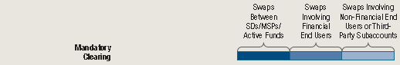





#### HOOP considerations

❶**Trade Execution** eligible swaps traded on electronic platform e.g. **SEF Swaps Exchange Facility** ❷**Derivatives Clearing Member DCM** - one or many ❸**Affirmation/ Confirmation** OTC trades affirmed/confirmed on **T+0** in order to be cleared (currently, *trade date+10-plus business days* paper confirmations return from counterparties ⇨ must use electronic platforms (e.g., DTCC and MARKITWIRE) for T+0 basis ❹**Margining** must post Initial Margin and daily variation margin ❺**Pricing** in order to agree on margins, must receive clearing houses prices ⇨ different from internally generated prices? process for obtaining/ verifying prices? ❻**Risk Management** DCM/ Clearing House for counterparty risk management ❼**Trade Repositories** OTC swaps to be reported to trade repositories, similar to credit default swap deals currently in **Depository Trust & Clearing Corporation DTCC Trade Information Warehouse TIW** ❽**Legal Document** ❾Clearinghouse prices for accounting purposes? Reconciliation between internally generated and clearing house price sufficient How to account for variation margin? ❿**Integration and workflow** ⬩Training and documentation ⬩Controls

#### HOOPP Plan

❶**Key deliverables** ⬩Configure SCD to calculate/ post daily **Variation Margin VM** (using FX rates and 'data consolidator' prices) ⬩Recon SCD VM to DCM VM ⬩Shadow replication processing (for reporting) ⬩FX flattening per DCM ⬩SCD Accounting configurations for VM ⬩SCD to NT Cash Recon, adjustments for VM Netting ⬩Revise collateral process to deliver initial margin on T+1 ⬩Setup collateral pools and haircuts for each DCM ⬩Modify reports for VM/DCM changes ❷**Recon's (IRS and CDS)** HOOPP to MARKIT Position Recon ❸Data Integrity Reports (IRS/CDS) ⬩Trade flow data integrity ⬩Price feed data ⬩FX feed data integrity ❹**IT infrastructure** FTP, batch jobs and scheduling ❺**Operational procedure/ process change** training/ documentation

#### System capabilities for OTC derivatives central trading and clearing

❶Support enterprise data management for a 360° view of risk/ performance ❷Automate position valuation & generation of variation margin ❸Automatically reconcile discrepancies against transacting counterparty ❹Support full straight-through-processing (STP) workflow for OTC swaps ❺Provide transparency in trade transaction flow for full disclosure ❻Communicate real-time details of trades and collateral to all relevant parties ❼Provide broad instrument coverage that includes centrally & bilaterally cleared trades plus instruments outside of Dodd-Frank ❽Support real-time reporting to reflect the most up-to-date view of positions and trades

#### Straight Through Processing STP

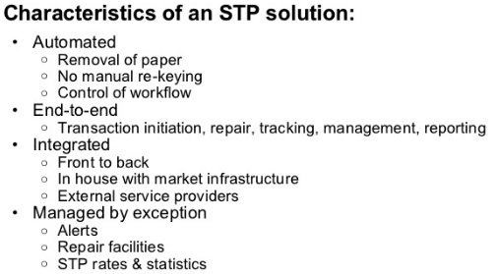

#### Market infrastructure

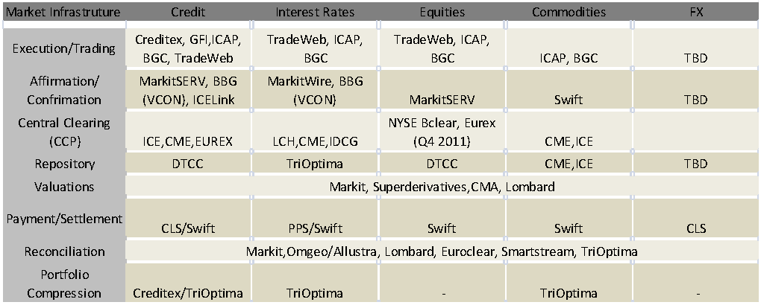

#### HOOPP Process for transacting & clearing a trade

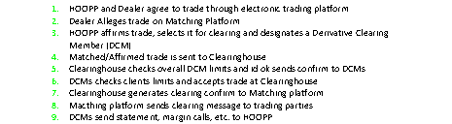

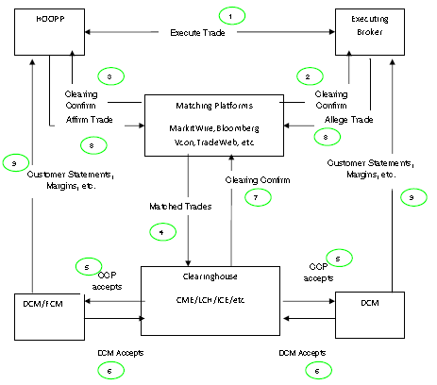

## SIMCORP

🕮**HOOPP****,** **More on HOOPP** 🕮**HOOPP Treasury** 🕮**Securities Lending & Collateral Administration** 🕮**Workflow Equity, Derivatives, FX, Fixed Income** 🕮**SCD Equity** 🕮**SCD Fixed Income** 🕮**SCD Upgrade** 🕮**Fair Value Continuity** 🕮**More on SCD**

🕮**SCD Lexicon**

#### On SCD EQUITY

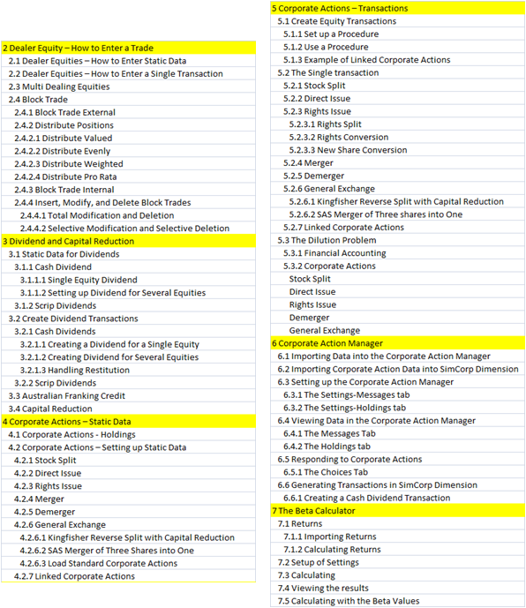

#### On Collateral

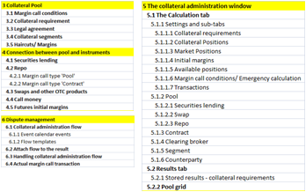

#### On SCD Fixed Income

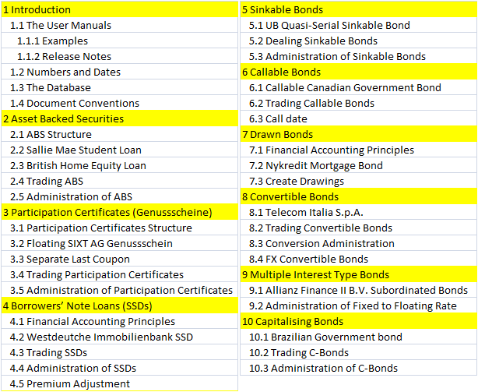

#### Functions & Modules

##### SCD Solutions Portfolio

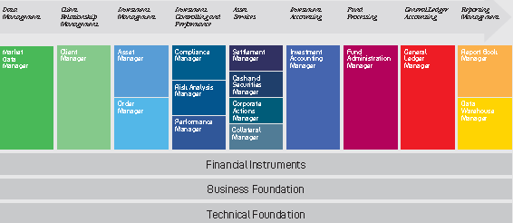

##### SCD Data warehouse

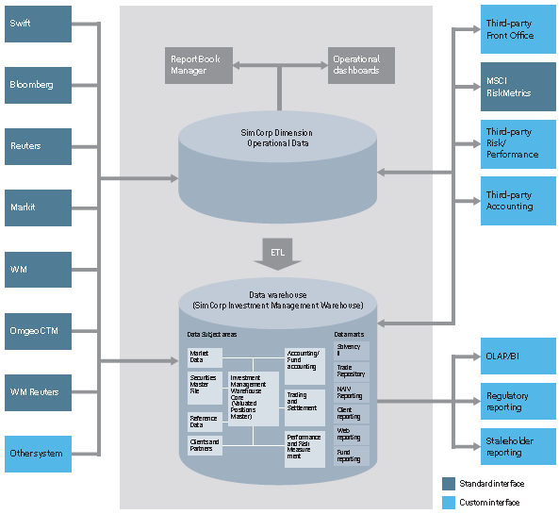

|  |  |
| --- | --- |
| **ARCHITECTURE**  · Single source of truth  · Data harmonization  · Sign-off functionality  **DATA MODEL**  · Multi GAAP  · Multi Entity  · Decomposition  · Data History | **ETL MANAGER**  · Logic-based mapping  · Management database for ETL logic  · Configurable validation logic  · Logging of all ETL processes  · ETL logic managed via portal  · Automatic dispatch of status notifictions |

# AIDC Financial Management and Treasury

IT integrated with Financial Management (treasury, risk management and quantitative applications) Treasury and Commodities responsible for pricing AUD, trading electricity and wool derivatives, new pricing models: *endowment warrants*, *share ratio options* and or *exotic options*. One of main activities was to integrate diverse range of treasury products into a single treasury system •**Size**: $5B in managed assets- total income $40M- Project finance, equity & debt- Treasury- Trading government & corporate debt instruments

# Manulife OTTI (Other than Temporarily Impaired)

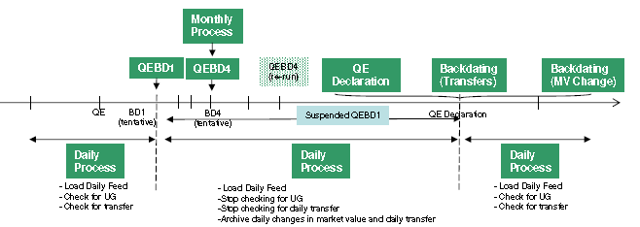

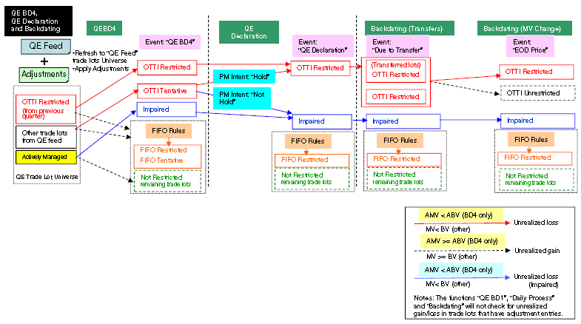

# AIA/AIG

• Underwriting, claims and POS (Policies) • Products: Endowment (EA), modified anticipated endowment special (MAES), Life endowment special (LES), Yearly Renewable Term Assurance (YRTA) • Riders: Accidental death benefit (ADB), Accident medical reimbursement (AMR), Accident Hospital income (HI) **AIG Size** •AIG: #1 market cap $200B (2000), 91.3% life premium in Asia; AIA revenue $5B, PCI Bank, PhilAmlife, AIG SunAmerica, AIG Private Bank

## P&C

⬩Develop automobile insurance ⬩3rd-party liability ⬩Accident benefits ⬩Uninsured motorist coverage ⬩General provisions, definitions, exclusions ⬩Statutory conditions,b prescribed conditions (BC), mandatory conditions (Nova Scotia), policy conditions (Quebec) ⬩Loss of or damage to insured car ⬩Endorsements ⬩Applications, underwriting

## AIG Credit Card

AIG Credit Card Company Philippines owned by AIG Consumer Finance and sold to PhilAm Savings bank •Rapid prototyping •Payment Card Industry Data Security Standard (PCI DSS) •Marketing & acquisition practices, effective campaigns •Tech infrastructure supporting credit & debit products, services, fraud detection, security, compliance, marketing, distribution & sales

# CIBC Control

## CIBC 20 Services (Financial)

|  |  |
| --- | --- |
| AUDIT | Admin of Non-Core loans. |
| FINANCE | Advertisement Costs |
| GLOBAP OPS | AR, AP |
| HR | Business Analysis |
| LEGAL | Call Centre Supports products for Commercial Banking |
| MARKETING | Compliance |
| RETAIL | Fees (Directors, OSFI) |
| RISK | Financial Analysis |
| TECH SERV | Financial Ombudsman |
| WORLD MARKETS | Financial Risk Support |
| WEALTH | HR - Compensation |
|  | HR - Compliance |
|  | Management Costs |
|  | Project Management |
|  | Resource Centre - reports (M&A, Green sheets, Prospectus') and internet searches |
|  | Stock services |
|  | TI/TS Application Support Cost |
|  | TI/TS Technology Services Cost |

## CIBC Processes (FCU)

|  |  |
| --- | --- |
| BUSINESS_PROCESS | SUB_PROCESS |
| A/P | Accrual |
| Interco loan | Account for loan payable to treasury |
| Outstanding Cheques Clearing | Accounting Outstanding Cheques |
| Accrue Liabilities | ID significant individual liabilities |
| Accrue Obligations related to Securities | Record Repos Position |
| Record Securities Sold Short Position |
| Calculate/ Collect Mortgage Income | Originate a mortgage - recording of acquisition costs on mortgage origination |
| Income Taxes Note Disclosure | Compilation of Note Disclosure |
| Note Disclosure Aging of Deposits | Demand, Notice & Term Deposits |
| Note Disclosure IR Sensitivity | Loans & Deposits Aging & yields |
| Note Disclosure Mortgage and customer Loans | Mortgages & Consumer Loans |
| Note Disclosure Segment info | Establish customer CIF (name, address, & permanent information) |
| Defer Acquisition Cost on Mortgages | Calculate/invoice acquisition cost |
| Prepare amortization schedule |
| Defer Payments to Loblaws | Defer Acquisition Cost of acquiring credit products and points |
| EUC Applications | General Controls |
| Financial Statements Preparation | Compilation of Notes to the Financial Statements |
| Get a mortgage loan on the books | Funding Mortgages |
| Get the Loans on the books | Attach credit - PLC |
|  | Disburse Funds for Personal Loans |
| GL/source system balancing | Automatically compare ICBS and GL:M balances |
| HR | Bi-weekly review of payroll register (Including New Hire, Transfers, and Terminations) |
| ICBS Application Controls | AS400 Recovery |
|  | Change Management |
|  | ICBS Incident & Problem Management Process |
| ICBS Information Security | Security Administration |
| Maintain customer demand (chequing) deposit | Calculate and accrue daily interest |
| Maintain interest rates |
| Transaction Cheque Clearing |
| Transaction processing - EFT |
| Transaction processing - POS, ABM, Internet, TB - on Tandem |
| Maintain customer loan | Maintain interest rates in ICBS |
|  | Recognize interest calc & accrual |
|  | Transaction Processing - Payments or PLC cheques |
| Maintain customer notice (RSP) deposits | RSP Renewal |
| Maintain customer notice(savings) deposit | Transaction processing - Internet, ABM, TB (transfers only) - on Tandem |
| Maintain residential mortgages | All sub-process |
|  | Apply payments to Int. income and principal / Accrue Int. at month-end |
|  | Determine mortgage interest rates |
| Manage Bank Accounts | Balance & Settle A/P Bank Account |
|  | Balance & Settle ABM Unpostable, All EFT Return Bank Accounts |
|  | Balance & Settle ABM, POS, RB, SCD, Plus, Outbound EFT Bank Accounts |
|  | Balance & Settle Cheque Clearing |
|  | Balance & Settle EFT Bank Account |
|  | Balance & Settle General Operating, Treasury, Mortgage, EFT, USD Bank |
|  | Balance & Settle Guarantee Payments Bank A/C Drafts & MO |
|  | Balance & Settle Guarantee Payments, Cheq Clr Bank A/C Loans |
|  | Balance & Settle Payroll Bank |
|  | Balance & Settle Treasury Bank A/C |
| Manage Suspense Accounts | Manage Operating Suspense A/C |
| Other Misc Suspense Accts | Accounting Items in Suspense A/C |
| Purchase & pay for non interest expenses | Pay Outside Services (Amortized Trailer fees / Commissions) |
| Pay Other Misc Expenses |
| Purchase & pay other expenses | Pay Other Expenses |
| Recognize deferred taxes | Book Monthly Tax Recovery |
|  | Determine monthly tax rate - Acct |
| Recognize fee income | Recognize Amicus ABM Surcharge |
|  | Recognize Interac Charges (convenience fee auto charged for each customer txn) |
|  | Recognize Returned Cheque Fees |
| Recognize FOREX non-trading income | Recognize other income |

## CIBC 26 Processes (OPC) – 113 Sub-processes

|  |  |
| --- | --- |
| Process | Sub Process |
| Brokerage & Trade | Broker Services - Cash Processing |
| Broker Services- Collateral Management |
| Cash Management |
| Cash Management - Collection of Foreign Cheques |
| Cash Management-Cheque Issuance |
| Cash Management-Incoming wire payments/Cheque deposits |
| Cash Management-ISI Liasion Desk/Bank Reconciliation-Break Resolution |
| CP Issuance - Billing |
| CP Issuance - Book Based Maturity |
| CP Issuance - Physical Maturity |
| CP Issuance-DCS Settlement |
| CP Issuance-Physical Settlement |
| Domestic Equity /Bonds Settlements |
| Equity Arbitrage |
| Futures & Options Settlements |
| GIC Settlements |
| Institutional Equity Settlements - Equity Arbitrage |
| International Settlements |
| Money Market |
| Money Market DTC/FED Settlements |
| Money Market US Settlements- Physical Trades |
| Over The Counter Receipt of Securities |
| Over The Counter/Branch Receipt of Securities |
| Safekeeping |
| Security Lending and Borrowing |
| Segregation Management |
| Stock Transfers |
| UK Securities Lending |
| Compliance | COB Disclosure |
| Credit Mgt | Monitor Credit |
| Customer Satisfaction | Customer Complaints Management |
| Customer Restitution |
| Derivatives Settlement Operations | Confirmations |
| Post-Settlement Investigations |
| Pre-Settlement Investigations |
| Settlements |
| Foreign Exchange | Booking |
| Maintenance | Account Information Maintenance |
|  | Customer Information Maintenance |
|  | Operator Profile Maintenance |
|  | Suspense Account Maintenance |
| Manage and Monitor the Imperial vehicles | Execute Transactions |
| Identify Substitute and Replacement Assets |
| Reporting |
| Management Processes | Investments |
| Lending |
| Procedures Information |
| Regulatory Compliance |
| Sales Management |
| Origination | Adjudication |
|  | Application Processing |
|  | Funding & Disbursement |
| Origination (Commercial) | Adjudication (Commercial) |
| Funding & Disbursement (Commercial) |
| Outsourcing | Outsourcing - ADP |
| Payments Processing | Cash Settlements |
| Credit Administration |
| Investigations |
| Reports Balancing |
| Sanction Filtering |
| Validation & Message Repair |
| Portfolio Management | Credit Derivative Hedging |
| Credit Derivative Trading |
| Establish Portfolio Strategy |
| Hedging |
| Portfolio Management |
| Proprietary Products | Account Maintenance (CM, Talvest and SI only) |
| Account Opening (PPS) |
| Account Opening/Closing/Transfers (CM/Talvest only) |
| Client Tax Reporting / Tax filing |
| Financial Transactions/ Adjustments |
| Trust Accounting |
| Registered Products | 3rd Party Settlements - Brokerage |
| 3rd Party Settlements-Fixed Term |
| Account Transfers (Internal)-Fixed Term |
| Adjustments - Brokerage |
| Adjustments-Fixed Term |
| Client Support-Fixed Term |
| Deposits-Fixed Term |
| GL Reporting-Fixed Term |
| Monitoring & Compliance - Brokerage |
| Tax Reporting - Brokerage |
| Tax Reporting (GIC Withdrawals)-Fixed Term |
| Transfers - Brokerage |
| Withdrawals- Brokerage |
| Withdrawals-Fixed Term |
| Sales Fulfillment | Lending - Personal Loan Products |
|  | Lending - Small Business Loan Products |
|  | Small Business Account |
| Sales Origination | Account Open - Personal Deposits |
|  | Account Open - Small Business Deposits |
| Security &Control | CSP Application Processing |
|  | Database Control |
| Service - Inventory Control | Ordering |
| Servicing | Annual Statement |
| Call Center |
| Discharge |
| Early Renewals |
| Product Changes |
| Renewals |
| Taxes |
| Transaction Processing |
| Servicing (Commercial) | Annual Portfolio Review |
| Renewals (Commercial) |
| Transaction Processing (Commercial) |
| Technology Mgt | IT Access Control |
| 3rd Party Mutual Funds | Processing |
| Trade Finance | Documentation Verification |
| Transaction Processing | Centralized Instruments Processing |
| Cheque Processing |
| Deposit Processing |
| Inter Branch Payments (IBP) Processing |
| Withdrawal Processing |
|  |  |

## CIBC Legislative Compliance Management (LCM)

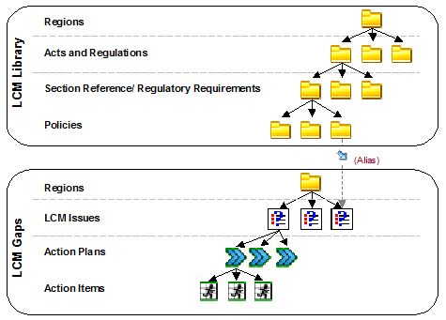

# British Columbia Workplace Technology Services

## Balance Scorecard and Performance Measures

#### Learning & Growth - Customers

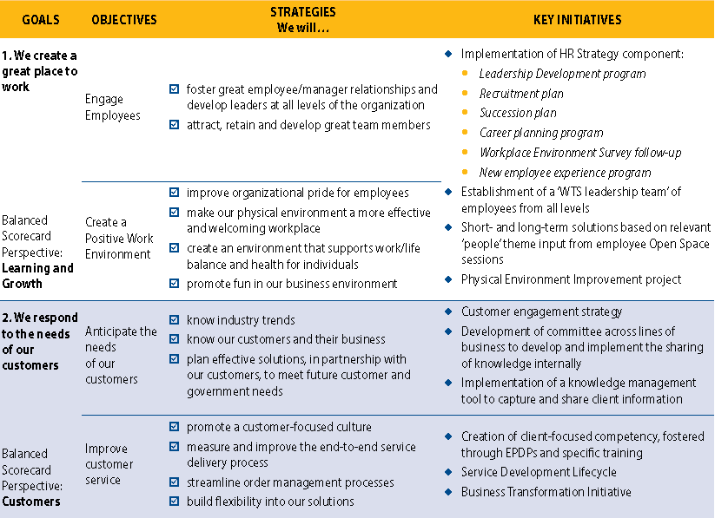

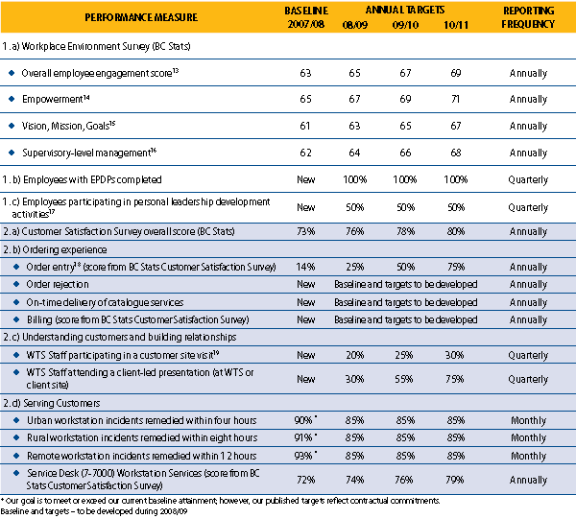

#### Internal Business Processes and Financial

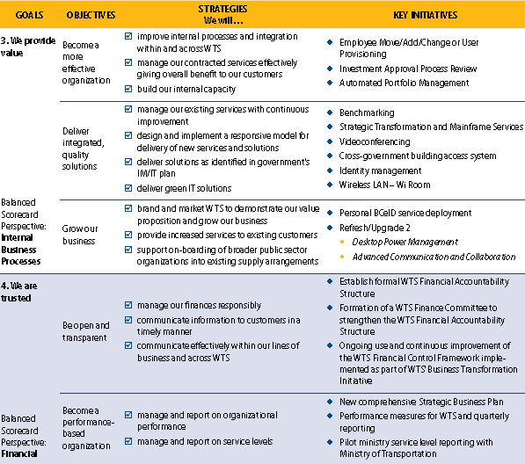

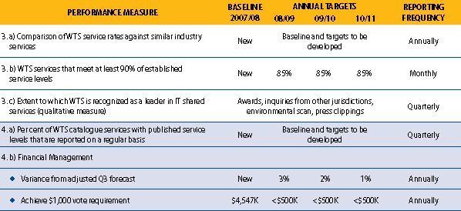

## Corporate Accounting System (CAS)

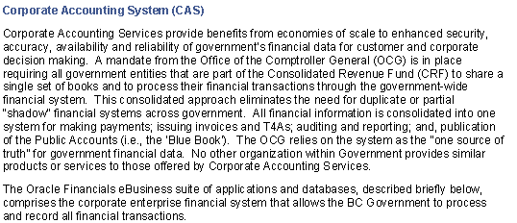

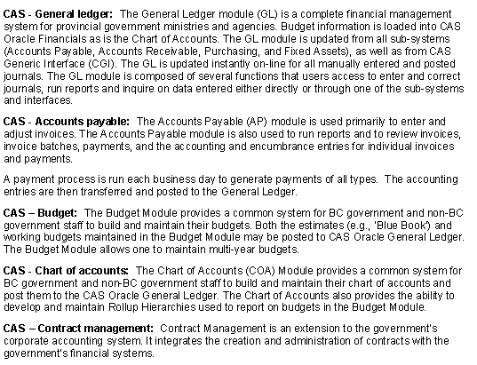

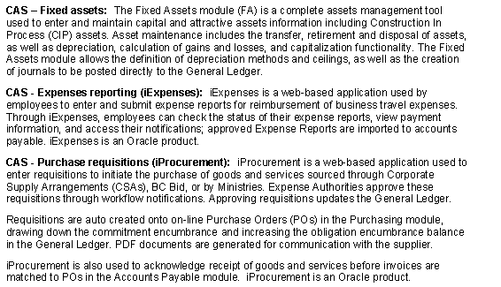

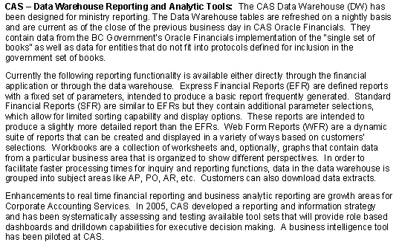

## Business Transformation Initiative (BTI)

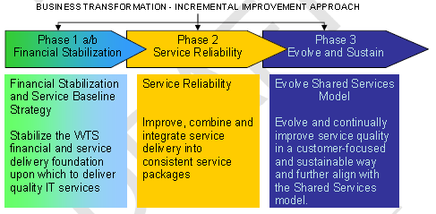

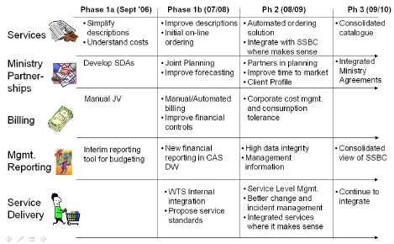

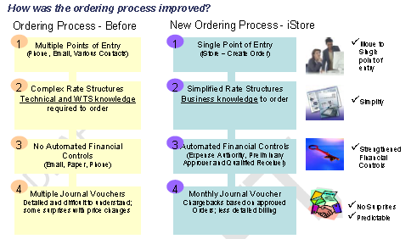

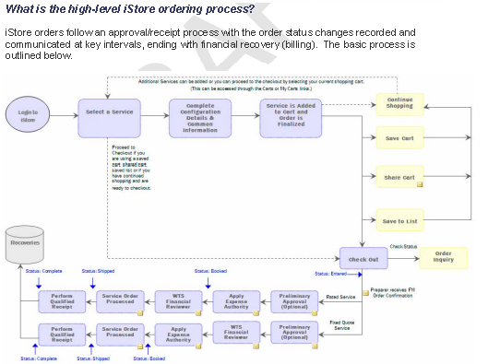

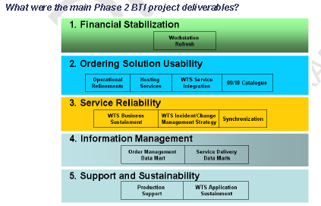

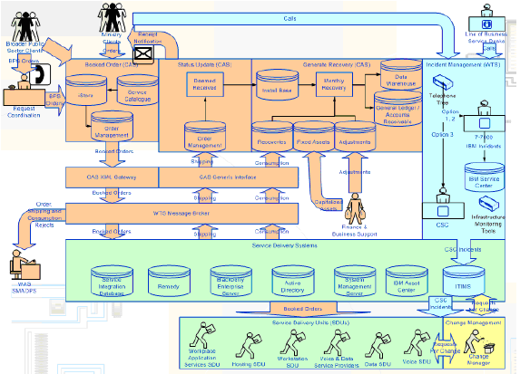

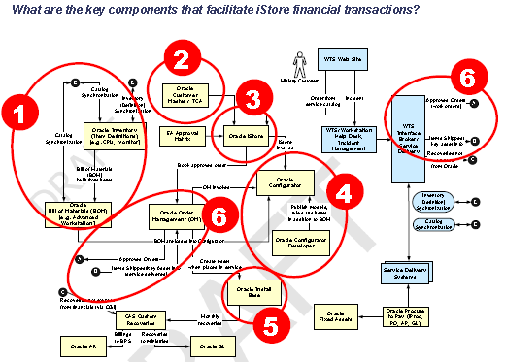

# CIBC Mellon

## History

CIBC Mellon was founded in 1996 after CIBC joined with Mellon Financial Corporation in a 50-50 joint venture named CIBC Mellon **Global Securities Services (CMGSS)**. The following year, 1997, CIBC purchased a 50% stake in The R-M Trust Company from Mellon, which would become CMGSS's sister company, **CIBC Mellon Trust Company (CMTC)**. CIBC Mellon acquired the Pension and Institutional Trust businesses from Canada Trust in 1997 and the global custody business from the Bank of Montreal in 1999. In 2002 CIBC Mellon acquired TD 3rd party investment fund custody business.

##### Cash Processing, AR, Revenues Fees

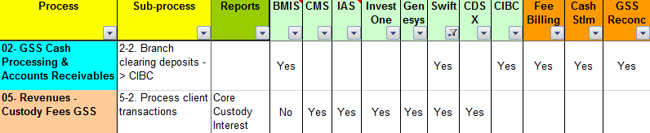

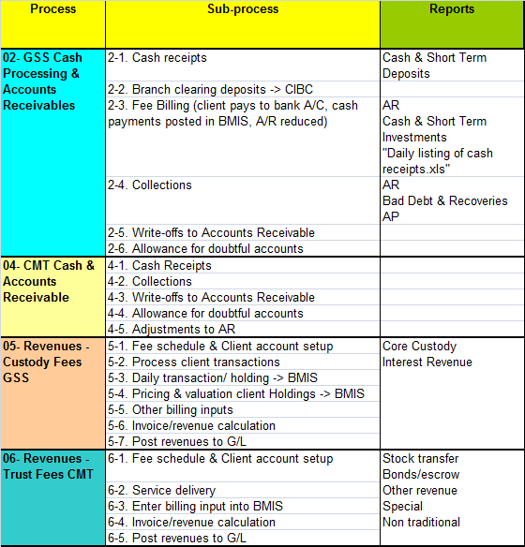

## Business & Process

⬩Distribution and service fees earned from mutual funds as percentage of average assets of mutual fund investment portfolios managed or administered by Mellon ⬩Asset Servicing Sector driven by: level of transaction activity and extent of services provided including custody, accounting, administration, daily valuations, performance measurement, securities lending, foreign exchange trading and investment manager back-office outsourcing, market value of assets under administration and custody ⬩Institutional trust and custody revenue/fees depend on volume of transactions in CM clients’ accounts + number of accounts; types of services e.g. performance analytics; level of assets under custody or administered. Revenue includes securities lending revenue, spread earned on reinvestment of cash posted by borrower as collateral; percentage sharing of that earned spread with custody clients who own securities ⬩FOREX trading revenues ⬩Payment solutions & investor services fee revenue**:** cash management revenue, Investor Services revenue, and revenue earned by Financial Markets ⬩Treasury Services/ Activity sector: ⮚Financing-related revenue: returns from corporate-owned life insurance; gains/ losses on securitizations; letters of credit & acceptance fees; loan commitment fees; gains/losses on loan sales/lease residuals. ⮚Equity investment revenue: realized/unrealized gains/losses on venture/non-venture capital investments

## MIS Dashboards

#### Balance Scorecard Internal - GSS Trade Settlements



#### Balance Scorecard Internal - CMT Securities Transfer

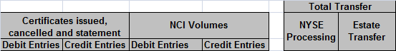

#### Balance Scorecard Internal - CMT & GSS Assets under Administration



#### Balance Scorecard Finance

|  |  |
| --- | --- |
|  |  |

#### Balance Scorecard Client

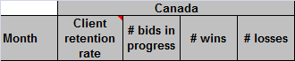

#### Balance Scorecard Learning & Growth



## Scope

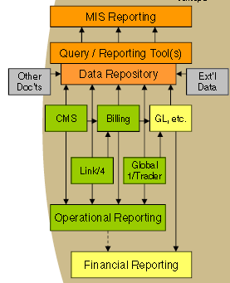

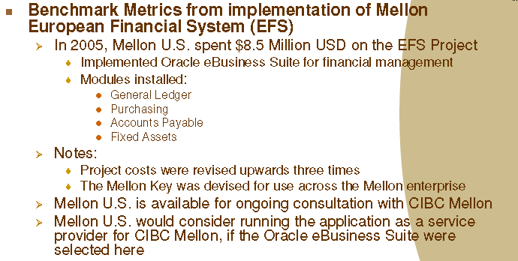

## Project Plan

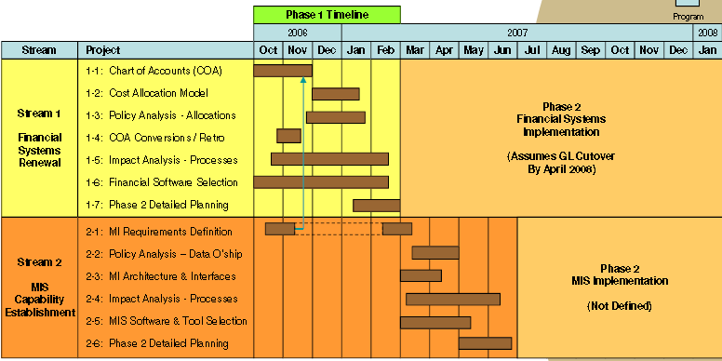

# CIBC CAD Chief Accountant Scorecard 2005

## Operations

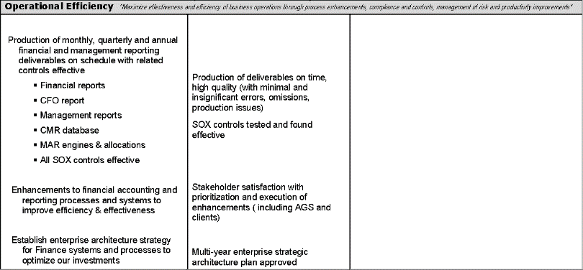

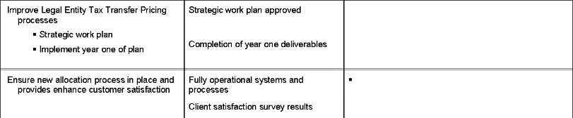

## Finance

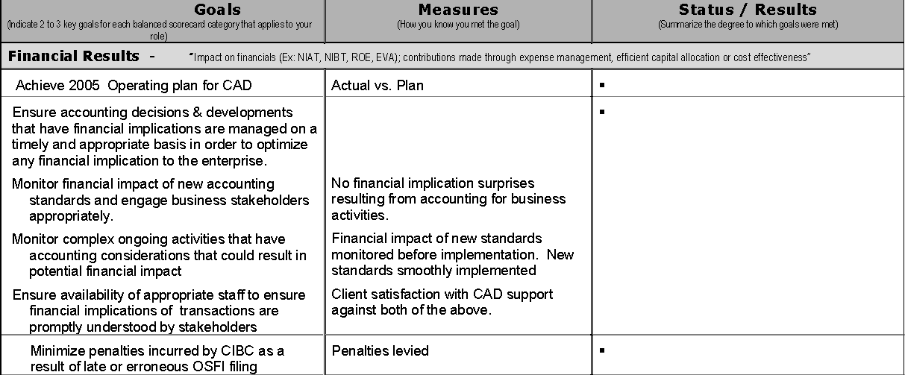

## Customer/Client

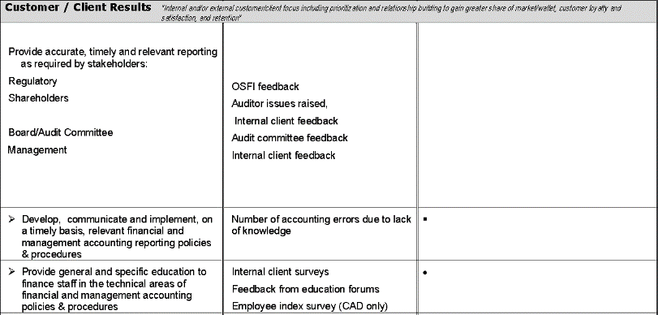

## Growth

